FAST Alumni & Faculty Portal

Functional Specification



Submitted to:
Sir Waqas Zyad

Submitted by:

Mahhek Tahir | L12-5422
Khizra Samad | L12-5419
Asma Shaheen | L12-5410
Bilal Farooq Ahmad | L12-5406

27 February, 2014

National University of Computer & Emerging Science

Document Overview

Title | Functional Specification | Version | 1.0
Project | FAST Alumni & Faculty Portal | Status | Draft
Client | FAST University | Type | Internal
Author | Khizra Samad | Last Save | 27 February, 2014

Revision History

Ver # | Rev Date | Author | Description
1.0 | November 6, 2013 | Project Team | Final Version
2.0 | 27 February, 2014 | Khizra Samad | Draft

Distribution List

Name | Role | Distribution Date | Version
Waqas Zyad | Project Advisor | 27 February, 2014 | 2.0
Mahhek Tahir | Project Team Member | 27 February, 2014 | 2.0
Khizra Samad | Project Team Member | 27 February, 2014 | 2.0
Asma Shaheen | Project Team Member | 27 February, 2014 | 2.0
Bilal Farooq Ahmad | Project Team Member | 27 February, 2014 | 2.0

Table of Contents

1. Introduction 6
1.1 Purpose 6
1.2 Scope 6
2. Overview 7
2.1 Product Perspective 8
2.1.1 System Interfaces 9
2.1.2 User Interfaces 9
2.1.3 Hardware Interfaces 9
2.1.4 Software Interfaces 9
2.1.5 Communications Interfaces 9
2.2 Product Functions 9
2.2.1 Inputs 9
2.2.2 Outputs 9
2.3 User Characteristics 10
2.4 Constraints 10
2.5 Assumptions and dependences 10
2.6 Prioritization of requirements 10
3. Functional Requirements 11
4. Non Functional Requirements 12
5. Actors 13
5.1 Admin: 13
5.2 Alumni: 13
5.3 Faculty: 13
5.4 Student: 13
5.5 General User: 14
6. Uses-Cases 14
6.1 Create Login 14
6.2 Admin View Dashboard 15
6.3 Admin View Faculty Profile 15
6.4 Admin View Alumni Profile 15
6.5 Admin View Student Profile 16
6.6 Verify Alumni 16
6.7 Verify Student 16
6.8 Block Student 17
6.9 Manage Job Portal 17
6.10 Admin Post Scholarship 18
6.11 Manage Scholarships 18
6.12 Manage Discussion Forum 19
6.13 View Jobs and Projects 19
6.14 View Job Detail 20
6.15 View Project Detail 20
6.16 Search Jobs 21
6.17 Search Project 21
6.18 Apply For Job 22
6.19 Apply For Project 22
6.20 Student View Scholarship 23
6.21 Student Apply for Scholarship 23
6.22 Login 24
6.23 Create Topic on Forum 24
6.24 Post Comment on Forum 25
6.25 Mark Comment Inappropriate 25
6.26 Post a Job 26
6.27 Post A Project 26
6.28 Views Student’s Profile - Applied for Project 27
6.29 User Views Student’s Profile - Applied for Job 28
6.30 User Registration 29
6.31 User Profile Creation 30
6.32 Edit User Profile 31
6.33 Manage Admin 32
6.34 Search Alumni Profile 32
6.35 Search Student Profile 33
6.36 Search Faculty Profile 34
6.37 Download Profile 35
6.38 Logout 36
6.39 Forgot Password 36
6.40 View Posted jobs and candidate applied to Job 37
6.41 Reject a candidate application 37
6.42 Accept a candidate application 38
6.43 View applied Jobs 39
6.44 View recommended candidates 39
6.45 View Recommended jobs 40
6.46 Send messages 40
6.47 View count of new Message 41
6.48 Notification for received Messages 41
6.49 Delete conversation 42
6.50 Mark conversation as read 43
6.51 Traceability Matrix 43
7. System Architecture Diagram 46
8. Data Model 47
8.1 E-R Diagram 47
8.2 Data Flow Diagram 48
8.2.1 Overall system 48
8.2.2 Profile Management 49
8.2.3 Job portal 50
8.2.4 Forum 51
9. Object Model 52
10. GUI(s) 53
10.1 Home Page 53
10.2 Login Page 53
10.3 Registration Page 54
10.4 Profile Page 55
10.5 Edit Profile Page 56
10.6 Edit Password Page 57
10.7 Post Job Page 57
10.8 Search Job Page 58
10.9 Job Detail Page 59
10.10 Discussion Forum Page 59
10.11 Topic Detail Page 60
10.12 Create Topic Page 61
10.13 Scholarship Page 61
10.14 Alumni Search Result Page 62
10.15 Faculty Search Result Page 62
10.16 Student Search Result Page 63
10.17 Admin Dashboard 63
10.18 Add New User Page 64
10.19 Manage Alumni Page 64
10.20 Manage Faculty Page 65
10.21 Manage Jobs Page 65
10.22 Manage Student Page 66
10.23 Manage Scholarship Page 66
10.24 Manage Discussion Forum 67
11. References 67

FAST-NU Library Requirements Specification

Introduction

This document describes the software requirements of FAST Alumni and Faculty Portal in detail. The purpose of this document is to specify software requirements include both functional and non-functional requirement of system along with the traceability matrix and the document also demonstrates the Dataflow, ER, Object Model Process Flow Diagrams and basic GUI of system.

Purpose

This document provides a complete description of all the functions and specifications of FAST Alumni and Faculty Portal. The document provides information regarding system interfaces, user interface, constraints, hardware and software requirements mainly the functional and non-functional requirements. The document also illustrates the end users of system and the method by which they interact with the system through its interfaces. The stakeholders of this system will be Fast administrator, current Students, Alumni, OSAF, Faculty, Companies, HEC and general web user.
Following are the technique we used for requirement elicitation
- Interviews and meetings with stakeholders
- Feedback and Discussion with stakeholders
- Understanding and Observing other existing dashboards systems

The intended audiences for this document are the domain holders and the system developers.

Scope

FAST Alumni and Faculty Portal will be a web based application. This system will only target the Lahore campus at the start however, it will be deployed in other campuses as per requirement and need. The system will be accessible within university premises and online outside the university as well. Only university Faculty, Students and alumni can register and use this system. Following are the main modules of system
- Administration
- Faculty
- Alumni
- Current Students
- Forum
- Job Portal
- Scholarship Portal

Overview

In FAST currently there is no active system which stores Alumni and Faculty information. Whenever University or Faculty members need to approach any alumni or other faculty members they have to face a lot of difficulties and sometime it takes many days to get the contact details of alumni member or any other faculty member. Lack of a proper platform to integrate all facilities regarding job offerings, scholarship postings and project listing has been always a major issue for FAST administration. There was a need felt for a system with features which can allow the administration and faculty member to access contact details of alumni and other faculty members. It will allow the users to design their own web page. On this webpage these members will be able to add their details regarding academic, professional and ongoing projects. It should also provide a stage for job postings, scholarships and mini-projects listings and a forum where they can create discussion topics and post comment on topics. It will be highly valuable and useful system for students because it will provide a professional, comprehensive career and employment related service to students and alumni with no charges.

Alumni


Business Process:
Admin
Business Process:
Student
Alumni & Faulty Portal


Business Process:
Faculty

Product Perspective

FAST Alumni and Faculty Portal will be a web based application. This system will only target the Lahore campus at the start however; it will be deployed in other campuses as per requirement and need. The system will be accessible within university premises and online outside the university as well. Only university Faculty, Students and alumni can register and use this system but some features of system also visible to general web user.

Following five will be main modules/View for proposed system

Admin View: System will provide interface to create login for student, alumni and faculty. System will provide interface to approve student register request and block /unblock user. System will provide interface to manage user (student, alumni and faculty) profile information, to manage job and scholarship posting and to manage forum.

Alumni View: System will provide interface to view, search and download student and faculty profile. Alumni will be able to login to system. System will provide a dashboard with following links

- Edit profile
- Post Job / Project
- View students applied to job
- View Forum

Faculty View: System will provide interface to view, search and download student and faculty profile. Faculty will be able to register and login to system. System will provide a dashboard with following links

- Edit profile
- Post Job / Project
- View students applied to job
- View Forum

Student View: System will provide interface to view, search and download student and faculty profile. Student will be able to login to system. System will provide a dashboard with following links

- Edit profile
- View Job portal
- View Scholarship
- View Forum

General User View: System will provide interface to view, search and download student and faculty profile.

System Interfaces
The system includes an online interface for all users, accessed through a web-browser over internet.

User Interfaces
The user interface contains screens or forms containing controls and menus for registration, login, job/project posting, scholarship posting, add forum topic and create comment on forum. Each type of user will have specific interface as per role. All users must have internet connection with good speed.

Hardware Interfaces
All components must be able to execute on personal computer

Software Interfaces
- Programing language: Ruby on Rails (ROR) will be used for development.

- Database: MySQL will be used.

Communications Interfaces
All users of this system will use TCP/IP interface for communication with the server via internet.

Product Functions
FAST Alumni and Faculty Portal relates following estimated functional inputs and outputs of production function.

Inputs
FAST Alumni & Faculty Portal basic input resources that contribute to project are:
- User profile information
- User registration information
- Job Posts
- Scholarships posts
- User queries
- User accounts handling
- Job applications

Monitoring them will allow deciding merits of one intervention over another and, it will help to track performance over time.

Outputs
FAST Alumni & Faculty Portal basic outputs services delivered by project are:
- Number of online user profile handling
- Online Job application submitted and processed (Internal & External)
- Scholarships application submitted and processed

- User queries answered and feedback received
- User accounts administration
- Stakeholders co- ordinated

Monitoring outputs will allow giving an immediate measure of progress

User Characteristics
There are six different users of this system Admin, Student, Faculty Member, Alumni, University Management and General Web User. All should have basic computer knowledge and web browsing.

Constraints
System shall use the any freeware technology for development.

Assumptions and dependences

- FAST National University will foster support in succeeding project goals and objectives.
- Faculty and management feedback/response will be available where needed.
- The project is designated to be deployed in FAST University and will lead the effort to facilitate University in having an automated process of offering internal and external job opportunities to the students.

Prioritization of requirements
All high priority requirements are crucial and will be implemented in the first release of the software.

Functional Requirements

Ref # | Explanation
FR01 | System shall allow user to create logins.
FR02 | System shall allow user to view dashboard.
FR03 | System shall allow user to view the faculty page / profile.
FR04 | System shall allow user to view alumni profile.
FR05 | System shall allow user to view student profile.
FR06 | System shall allow user to verify that alumni.
FR07 | System shall allow user to verify student.
FR08 | System shall allow user to block bogus accounts of the students.
FR09 | System shall allow user to manage job portal.
FR10 | System shall allow user to post Scholarships on the website
FR11 | System shall allow user to manage a Scholarships portal.
FR12 | System shall allow user to moderate discussion forum.
FR13 | System shall allow user to view jobs and projects.
FR14 | System shall allow user to view job details.
FR15 | System shall allow user to view project details.
FR16 | System shall allow user to Search jobs.
FR17 | System shall allow user to Search projects.
FR18 | System shall allow user to apply for job.
FR19 | System shall allow user to apply for project.
FR20 | System shall allow user to view scholarships.
FR21 | System shall allow user to apply scholarships.
FR22 | System shall allow user to login to the system.
FR23 | System shall allow user to create a topic on forum.
FR24 | System shall allow user to Post comment on a topic.
FR25 | System shall allow user to mark comment Inappropriate
FR26 | System shall allow user to post a job.
FR27 | System shall allow user to post a project.
FR28 | System shall allow user to view student’s profile who applied to a particular job.
FR29 | System shall allow user to view student’s profile who applied to a particular project.
FR30 | System shall allow user to register to the system.
FR31 | System shall allow user to create a profile.
FR32 | System shall allow user to edit profile.
FR33 | System shall allow user to manage admins.
FR34 | System shall allow user to search Alumni profile.
FR35 | System shall allow user to search other Student profile.
FR36 | System shall allow user to search Faculty profile.
FR37 | System shall allow user to download profile.
FR38 | System shall allow user to Log out from system.
FR39 | System shall allow user to change password.
FR40 | System shall allow User to see the Jobs he posts and Job Candidate who applied for a particular Job.
FR41 | System shall allow User to Reject a candidate application
FR42 | System shall allow User to accept a candidate application by calling him for interview.
FR43 | System shall allow User to see all Jobs posts applied and respective status of posted Job.
FR44 | System shall allow User to see recommended candidates again the jobs they posted
FR45 | System shall allow User to see recommended jobs for a user
FR46 | System shall allow User to send messages to other users
FR47 | User shall see a notification count along the inbox
FR48 | System shall allow users to view their conversations from all users
FR49 | System shall allow User delete messages in conversation.
FR50 | System shall allow conversations to be marked as read

Non Functional Requirements

Ref # | Explanation
NFR01 | The system shall include a user authorisation procedure where users must identify themselves using a login name and password.
NFR02 | The System services shall have an availability of 99%.
NFR03 | The System shall process a minimum of 8 transactions per second.
NFR04 | The access permissions for system data may only be changed by the system’s data administrator only.
NFR05 | All system data will be backed-up daily
NFR06 | System must be available 24 hours a day.
NFR07 | System must be compatible with Internet Explorer and Firefox browsers.
NFR08 | All processes can be made available after unplanned system downtime within 1 working day.
NFR09 | Up to 500 users can use system concurrently.  Up to 1000 users in total can use system simultaneously.
NFR10 | Usability requirements include:  - Well-structured user manuals  - Informative error messages  - Help facilities  - Well-formed graphical user interfaces
NFR11 | All external communications between the system’s data server and clients must be encrypted.
NFR12 | - The system shall not operate if the external temperature is below 4 degrees Celsius  - The system should no longer operate in case of fire  - The system should no longer operate if security attacks have become obvious
NFR13 | The system should have an ability to change the system to deal with new technology or to fix defects.
NFR14 | The system should have an ability to change the system to deal with additional international conventions such as languages, or number formats, styles.
NFR15 | System should provide ease with which a system or component can be transferred from one environment to another

Actors

Admin:
Admin is an important actor of Fast Alumni & Faculty Portal. Following is the list of functionalities that admin can perform:

- Create login for student, alumni and faculty.
- Approve student register request and block /unblock user.
- Manage users (student, alumni faculty and admin)
- Manage job and scholarship posting and to manage forum.

Alumni:
Alumni is another actor that plays an important role in this system. Following is the list of functionalities that alumni can perform:

- View, search and download student, alumni and faculty profile.
- Register and login
- Edit profile
- Post Job / Project
- View students applied to job
- View Forum
- Create topic
- Post Comment to topic

Faculty:
Faculty is another actor that plays an important role in this system. Following is the list of functionalities that faculty can perform:

- View, search and download student, alumni and faculty profile.
- Register and login
- Edit profile
- Post Job / Project
- View students applied to job
- View Forum
- Create topic
- Post Comment to topic

Student:
Student is another actor that plays an important role in this system. Following is the list of functionalities that student can perform:

- View, search and download student, alumni and faculty profile.
- Register and login
- Edit profile
- View Job portal
- View Scholarship
- View Forum
- Create topic
- Post Comment to topic

General User:
General User is another actor in this system. Following is the list of functionalities that student can perform:
- View, search and download student, alumni and faculty profile.

Uses-Cases

Create Login
Use Case ID: UC-01
Use Case Name | Create Login
Actors: | Admin
Brief Description | The purpose of this use case is to allow Admin to create logins.
Pre-condition | - User has access to the system URL.  - User has logged in to the system.
Main Flow | - User clicks on add user link from dashboard.  - The system displays the add user screen.  - User enters the email address and password.  - User clicks the Save button  - System saves user credentials.  - System displays the success message.
Post Conditions | - A new login has been created in system.  - User has received email notification along with credentials.
Alternate Flows | - User select option import from sheet.  - System displays dialog box to ask file location  - User selects file and click upload button.  - System validates file data.  - System displays the success message.
Exceptions | - System displays error message ‘User already exists’ if already exists in system.  - System displays error message ‘Fill all mandatory fields’ incase user skip any mandatory field.  - System displays error message ‘invalid data’ incase user enter data in the wrong format.

Admin View Dashboard
Use Case ID: UC-02
Use Case Name | Admin View Dashboard
Actors: | Admin
Brief Description | The purpose of this use case is to allow user to view dashboard.
Pre-condition | User has access to the system URL.
Main Flow | - User clicks on login link.  - The system display Login screen.  - User enters the email address.  - User enters the password.  - User presses the login button.  - The system validates the email address and password.  - The system displays the user (Admin) specific dashboard.
Post Conditions | The user has successfully viewed the dashboard.
Alternate Flows | None
Exceptions | None

Admin View Faculty Profile
Use Case ID: UC-03
Use Case Name | Admin View Faculty Profile
Actors: | Admin
Brief Description | The purpose of this use case is to allow user to view faculty page / profile.
Pre-condition | User has logged in to the system.
Main Flow | - User clicks on Manage Faculty link.  - The system displays the list of all faculty members on a new page.  - User clicks on View profile link.  - The system opens the faculty profile page.
Post Conditions | The user has successfully viewed the faculty profile page.
Alternate Flows | None
Exceptions | None

Admin View Alumni Profile
Use Case ID: UC-04
Use Case Name | Admin View Alumni Profile
Actors: | Admin
Brief Description | The purpose of this use case is to allow user to view alumni profile.
Pre-condition | User has logged in to the system.
Main Flow | - User clicks on Manage Alumni link.  - The system displays the list of all alumni on a new page.  - User clicks on View profile link.  - The system opens the alumni profile.
Post Conditions | The user has successfully viewed the alumni profile.
Alternate Flows | None
Exceptions | None

Admin View Student Profile
Use Case ID: UC-05
Use Case Name | Admin View Student Profile
Actors: | Admin
Brief Description | The purpose of this use case is to allow user to view student profile.
Pre-condition | User has logged in to the system.
Main Flow | - User clicks on Manage Student link.  - The system displays the list of all students on a new page.  - User clicks on View profile link.  - The system opens the student profile.
Post Conditions | The user has successfully viewed the student profile.
Alternate Flows | None
Exceptions | None

Verify Alumni
Use Case ID: UC-06
Use Case Name | Verify Alumni
Actors: | Admin
Brief Description | The purpose of this use case is to allow user to verify alumni.
Pre-condition | User has logged in to the system.
Main Flow | - User clicks on Manage Alumni link.  - The system displays the list of all alumni on a new page.  - User clicks on Verify link.  - The system changes the unverified status to verified.  - The system update the status in database
Post Conditions | The user has successfully verified the alumni.
Alternate Flows | None
Exceptions | None

Verify Student
Use Case ID: UC-07
Use Case Name | Verify Student
Actors: | Admin
Brief Description | The purpose of this use case is to allow user to verify student.
Pre-condition | User has logged in to the system.
Main Flow | - User clicks on Manage Student link.  - The system displays the list of all students on a new page.  - User clicks on Verify link.  - The system changes the unverified status to verified.  - The system updates the status in database.
Post Conditions | The user has successfully verified the student.
Alternate Flows | None
Exceptions | None

Block Student
Use Case ID: UC-08
Use Case Name | Block Student
Actors: | Admin
Brief Description | The purpose of this use case is to allow user to block accounts of the students.
Pre-condition | User has logged in to the system.
Main Flow | - User clicks on Manage Student link.  - The system displays the list of all students on a new page.  - User clicks on Deactivate link.  - The system changes the active status to deactive.  - The system updates the status in database.
Post Conditions | The user has successfully blocked the student.
Alternate Flows | None
Exceptions | None

Manage Job Portal
Use Case ID: UC-09
Use Case Name | Manage Job Portal
Actors: | Admin
Brief Description | The purpose of this use case is to allow user to manage job portal.
Pre-condition | User has logged in to the system.
Main Flow | - User clicks on Manage Jobs link.  - The system displays the list of all jobs on a new page.  - User clicks on View Link.  - The system opens the job detail page.  - User clicks on Delete Link.  - The system displays a confirmation prompt  - User clicks on ok  - The system deletes that job  - User clicks on Edit.  - The system displays job detail page in edit mode.  - User edits any field and clicks on update button  - The system saves the updated value in database.
Post Conditions | - User will view the job successfully.  - User will edit job successfully.  - System will save the updated value in database.  - User will delete the job successfully.
Alternate Flows | None
Exceptions | System displays error message ‘invalid data’ incase user enter data in wrong format during edit.

Admin Post Scholarship
Use Case ID: UC-10
Use Case Name | Admin Post Scholarship
Actors: | Admin
Brief Description | The purpose of this use case is to allow user to post scholarships.
Pre-condition | User has logged in to the system.
Main Flow | - User clicks on Post Job link.  - The system displays a page to enter related data.  - User enters data in all the mandatory fields.  - User clicks on Post button  - The system displays the confirmation message.  - The system adds the new job in database.
Post Conditions | - User has posted a new job successfully.  - New posted job will visible to all users.
Alternate Flows | None
Exceptions | - System displays error message ‘Fill all mandatory fields’ incase user skip any mandatory field.  - System displays error message ‘invalid data’ incase user enter data in wrong format.

Manage Scholarships
Use Case ID: UC-11
Use Case Name | Manage Scholarships
Actors: | Admin
Brief Description | The purpose of this use case is to allow user to manage scholarships.
Pre-condition | User has logged in to the system.
Main Flow | - User clicks on Manage Scholarships link.  - The system displays the list of all scholarships on a new page.  - User clicks on View Link.  - The system opens the scholarship detail page.  - User clicks on Delete Link.  - The system displays a confirmation prompt  - User clicks on ok.  - The system deletes that scholarship.  - User clicks on Edit.  - The system displays scholarship detail page in edit mode.  - User edits any field and clicks on update button  - The system saves the updated value in database.
Post Conditions | - User will view the scholarship successfully.  - User will edit scholarship successfully.  - System will save the updated value in database.  - User will delete the scholarship successfully.
Alternate Flows | None
Exceptions | System displays error message ‘invalid data’ incase user enter data in wrong format during edit.

Manage Discussion Forum
Use Case ID: UC-12
Use Case Name | Manage Discussion Forum
Actors: | Admin
Brief Description | The purpose of this use case is to allow user to moderate discussion forum.
Pre-condition | User has logged in to the system.
Main Flow | - User clicks on Manage Discussion Forum link.  - The system displays the list of all topics created by users on a new page.  - User clicks on View Link.  - The system opens the topic detail page.  - User clicks on Delete Link.  - The system displays a confirmation prompt  - User clicks on ok.  - The system deletes that topic.  - User clicks on Edit.  - The system displays topic detail page in edit mode.  - User edits any field and clicks on update button  - The system saves the updated value in database.
Post Conditions | - User will view the topic successfully.  - User will edit topic successfully.  - User will delete the topic successfully.
Alternate Flows | None
Exceptions | None

View Jobs and Projects
Use Case ID: 13
Use Case Name | View Jobs and Projects
Actors: | Student, Faculty Member
Brief Description | The purpose of this use case is to allow user to view jobs and projects.
Pre-condition | - User has logged in to the system.  - User has valid login credentials.  - The user profile has been created in the database.
Main Flow | - User clicks on Student or Faculty Member link.  - The system displays the specific dashboard.  - User clicks on Job link  - The system displays the list of all jobs and projects on a new page.
Post Conditions | User has viewed the jobs and projects successfully.
Alternate Flows | None
Exceptions | None

View Job Detail
Use Case ID: 14
Use Case Name | View Job Detail
Actors: | Student, Faculty Member
Brief Description | The purpose of this use case is to allow user to view job details.
Pre-condition | - User has logged in to the system.  - User has valid login credentials.  - The user profile has been created in the database.
Main Flow | - User clicks on Student or Faculty Member link.  - The system displays the specific dashboard.  - User clicks on Job link  - The system displays the list of all jobs and projects on a new page.  - User clicks on any job.  - The system opens the job detail page.
Post Conditions | - User has viewed the jobs and projects successfully.  - User has viewed the job detail successfully.
Alternate Flows | None
Exceptions | None

View Project Detail
Use Case ID: 15
Use Case Name | View Project Detail
Actors: | Student, Faculty Member
Brief Description | The purpose of this use case is to allow user to view project details.
Pre-condition | - User has logged in to the system.  - User has valid login credentials.  - The user profile has been created in the database.
Main Flow | - User clicks on Student or Faculty Member link.  - The system displays the specific dashboard.  - User clicks on Job link  - The system displays the list of all jobs and projects on a new page.  - User clicks on any project.  - The system opens the project detail page.
Post Conditions | - User has viewed the jobs and projects successfully.  - User has viewed the project detail successfully.
Alternate Flows | None
Exceptions | None

Search Jobs
Use Case ID: 16
Use Case Name | Search Jobs
Actors: | Student, Admin, Faculty Member
Brief Description | The purpose of this use case is to allow user to search jobs.
Pre-condition | - User has logged in to the system.  - User has opened specific (Student, Admin, Faculty Member) dashboard.
Main Flow | - User clicks on Job link  - The system displays the list of all jobs and projects on a new page.  - User clicks on Search Job link.  - The system asks to select search criteria.  - User selects the search criteria, enter values in mandatory field and click on search button  - The system displays the search results based on search criteria.
Post Conditions | - User has successfully searched job.  - User has successfully viewed search result.
Alternate Flows | None
Exceptions | - System displays message ‘No result found’ if record found against the search criteria.  - System displays error message ‘Fill all mandatory fields’ incase user skip any mandatory field.  - System displays error message ‘invalid data’ incase user enter data in wrong format.

Search Project
Use Case ID: 17
Use Case Name | Search Project
Actors: | Student, Admin, Faculty Member
Brief Description | The purpose of this use case is to allow user to search project.
Pre-condition | - User has logged in to the system.  - User has opened specific (Student, Admin, Faculty Member) dashboard.
Main Flow | - User clicks on Job link  - The system displays the list of all jobs and projects on a new page.  - User clicks on Search Project link.  - The system asks to select search criteria.  - User selects the search criteria, enter values in mandatory field and click on search button  - The system displays the search results based on search criteria.
Post Conditions | - User has successfully searched project.  - User has successfully viewed search result.
Alternate Flows | None
Exceptions | - System displays message ‘No result found’ if record found against the search criteria.  - System displays error message ‘Fill all mandatory fields’ incase user skip any mandatory field.  - System displays error message ‘invalid data’ incase user enter data in wrong format.

Apply For Job
Use Case ID: 18
Use Case Name | Apply For Job
Actors: | Student
Brief Description | The purpose of this use case is to allow User to apply for job.
Pre-condition | - User has logged in to the system.  - User has valid login credentials.  - The user profile has been created in the database.  - User has opened specific (Student) dashboard.
Main Flow | - User clicks on Job link  - The system displays the list of all jobs and projects on a new page.  - User clicks on any job.  - The system opens the job detail page.  - User clicks on Apply button.  - The system validates the user profile and skills against the requirement asked in job detail.  - The system displays the success message.  - The system saves the entry in database.
Post Conditions | The user has successfully applied for job through the system.
Alternate Flows | None
Exceptions | System displays the error message ‘you cannot apply to this job’ if user profile and skills set not matched with requirement asked in job detail.

Apply For Project
Use Case ID: 19
Use Case Name | Apply For Project
Actors: | Student
Brief Description | The purpose of this use case is to allow User to apply for project.
Pre-condition | - User has logged in to the system.  - User has valid login credentials.  - The user profile has been created in the database.  - User has opened specific (Student) dashboard.
Main Flow | - User clicks on Job link  - The system displays the list of all jobs and projects on a new page.  - User clicks on any project.  - The system opens the project detail page.  - User clicks on Apply button.  - The system validates the user profile and skills against the requirement asked in project detail.  - The system displays the success message.  - The system saves the entry in database.
Post Conditions | User has successfully applied for a project.
Alternate Flows | None
Exceptions | System displays the error message ‘you cannot apply to this project’ if user profile and skills set not matched with requirement asked in project detail.

Student View Scholarship
Use Case ID: UC-20
Use Case Name | Student View Scholarship
Actors: | Student
Brief Description | The purpose of this use case is to allow user to successfully view scholarship through the system
Pre-condition | - User login has been created by Admin.  - User has valid login credentials.  - The user profile has been created in the database.  - The user has access to the system URL.
Main Flow | - User clicks on Active Scholarships link.  - The system displays Active Scholarships screen.  - The user views Active Scholarships.
Post Conditions | The user has successfully viewed scholarship through the system.
Alternate Flows | System displays empty/null value on screen in case there is no active scholarship is available.
Exceptions | None

Student Apply for Scholarship
Use Case ID: UC-21
Use Case Name | Student Apply for Scholarship
Actors: | Student
Brief Description | The purpose of this use case is to allow user to successfully apply for scholarships through the system
Pre-condition | - User login has been created by Admin.  - User has valid login credentials.  - The user profile has been created in the database.  - The user has access to the system URL.
Main Flow | - User clicks on Apply To Scholarships link.  - The system displays Apply To Scholarships screen.  - The user clicks Apply button.  - System display success message
Post Conditions | The user has successfully applied for scholarship through the system.
Alternate Flows | None
Exceptions | None

Login
Use Case ID: UC-22
Use Case Name | Login
Actors: | Admin, Faculty Member, Alumni, Student
Brief Description | The purpose of this use case is to allow user to successfully log in to the system
Pre-condition | - User login has been created by Admin.  - The user profile has been created in the database.  - The user has access to the system URL.
Main Flow | - User clicks on login link.  - The system display Login screen.  - The user enters the email address.  - The user enters the password.  - User presses the login button.  - The system validates the email address and password.  - The system displays the homepage of the user.
Post Conditions | The user has successfully logged in to the system.
Alternate Flows | None
Exceptions | System displays error message “Invalid email or password” if user enters wrong / invalid email or password”

Create Topic on Forum
Use Case ID: UC-23
Use Case Name | Create Topic on Forum
Actors: | Admin, Faculty Member, Alumni, Student
Brief Description | The purpose of this use case is to allow user to successfully create a discussion topic on forum into the system
Pre-condition | - User login has been created by Admin.  - User has valid login credentials.  - The user profile has been created in the database.  - The user has access to the system URL.
Main Flow | - User clicks on Discussion Forum link.  - User clicks on Post discussion topic option.  - The system displays Post Discussion Topic screen.  - User enters title in Title field.  - User enters description in Description field.  - User clicks on save button  - System display success message
Post Conditions | The user has successfully posted a discussion topic into the system.
Alternate Flows | None
Exceptions | - System displays message to enter Title of topic if user does not enter data in field.  - System displays message to enter Description of topic if user does not enter data in field.

Post Comment on Forum
Use Case ID: UC-24
Use Case Name | Post Comment on Forum
Actors: | Admin, Faculty Member, Alumni, Student
Brief Description | The purpose of this use case is to allow user to successfully post comment against a discussion topic on forum into the system
Pre-condition | - User login has been created by Admin.  - User has valid login credentials.  - The user profile has been created in the database.  - The user has access to the system URL.  - A discussion topic has been created by other or same user.
Main Flow | - User clicks on Discussion Forum link.  - The system displays already created topic on Discussion forum screen.  - Users click on a discussion topic.  - User clicks on comment option.  - User enters description in Comment field.  - User clicks on enter button  - System display data entered in comment field.
Post Conditions | The user has successfully posted a comment into the system.
Alternate Flows | None
Exceptions | System displays an error message if user does not enter data in comment box and clicks enter.

Mark Comment Inappropriate
Use Case ID: UC-25
Use Case Name | Mark Comment Inappropriate
Actors: | Admin, Faculty Member, Alumni, Student
Brief Description | The purpose of this use case is to allow user to mark a comment inappropriate on a discussion topic on forum into the system
Pre-condition | - User login has been created by Admin.  - User has valid login credentials.  - The user profile has been created in the database.  - The user has access to the system URL.  - A discussion topic has been created by other or same user.  - A comment has been posted by other or same user against a discussion topic.
Main Flow | - User clicks on Discussion Forum link.  - The system displays already created topic on Discussion Topic screen.  - The system displays already posted comment(s) against discussion topic.  - User checks inappropriate check box followed by a comment to mark it inappropriate.  - System display checked mark against an entered comment.
Post Conditions | The user has successfully marked a comment inappropriate into the system.
Alternate Flows | None
Exceptions | None

Post a Job
Use Case ID: UC-26
Use Case Name | Post A Job
Actors: | Admin, Faculty Member, Alumni
Brief Description | The purpose of this use case is to allow user to post a project into the system
Pre-condition | - User login has been created by Admin.  - User has valid login credentials.  - The user profile has been created in the database.  - The user has access to the system URL.  - The user is authorized to post a project.
Main Flow | - User clicks on project link.  - The system displays Post a Project screen.  - User enters Project Title, Job type, Salary Range, Designation, Skill Required, and Notes  - User selects type of project as Internal or External  - User clicks on Post button.  - System displays a successful message of project post.
Post Conditions | The user has successfully posted a project into the system.
Alternate Flows | None
Exceptions | System displays message to enter Project Title, Job type, Salary Range, Designation, Skill Required data if user does not enter data in fields and clicks on post button

Post A Project
Use Case ID: UC-27
Use Case Name | Post A Project
Actors: | Admin, Faculty Member, Alumni
Brief Description | The purpose of this use case is to allow user to post a job into the system
Pre-condition | - User login has been created by Admin.  - User has valid login credentials.  - The user profile has been created in the database.  - The user has access to the system URL.  - The user is authorized to post a project.
Main Flow | - User clicks on project link.  - The system displays Post a job screen.  - User enters Company Name, Job type, Salary Range, Designation, Skill Required, Total Seats, Open Till, and Notes  - User selects type of job as Internal or External  - User clicks on Post button.  - System displays a successful message of job post.
Post Conditions | The user has successfully posted a job into the system.
Alternate Flows | None
Exceptions | System displays message to enter Project Title, Job type, Salary Range, Designation, Skill Required, Total Seats, Open Till, data if user does not enter data in fields and clicks on post button

Views Student’s Profile - Applied for Project
Use Case ID: UC-28
Use Case Name | Views Student’s Profile - Applied for Project
Actors: | Admin, Faculty Member, Alumni
Brief Description | The purpose of this use case is to allow user to view student’s profile who applied for a job through the system
Pre-condition | - User login has been created by Admin.  - User has valid login credentials.  - The user profile has been created in the database.  - The user has access to the system URL.  - The user is authorized to view student’s profile  - Student’s profile has been created and exit into the system.  - Student has applied for a particular project.
Main Flow | - User clicks on student link.  - The system displays Students screen.  - User enters First Name, Last Name or Roll No.  - User clicks on Search button  - System displays a list of students matches the entered criteria in search fields.  - User selects a student record (row) and clicks on view option.  - System displays selected student profile.  - User views user profile data/information.
Post Conditions | The user has successfully viewed student’s profile through the system.
Alternate Flows | None
Exceptions | - System displays message to enter First Name, Last Name or Roll No if user does not enter data in fields and clicks on search button  - System displays an error message if user enters invalid data in First Name, Last Name or Roll No and clicks on search button.

User Views Student’s Profile - Applied for Job
Use Case ID: UC-29
Use Case Name | User Views Student’s Profile - Applied for Job
Actors: | Admin, Faculty Member, Alumni
Brief Description | The purpose of this use case is to allow user to view student’s profile through the system
Pre-condition | - User login has been created by Admin.  - User has valid login credentials.  - The user profile has been created in the database.  - The user has access to the system URL.  - The user is authorized to view student’s profile  - Student’s profile has been created and exit into the system.  - Student has applied for a particular job.
Main Flow | - User clicks on student link.  - The system displays Students screen.  - User enters First Name, Last Name or Roll No.  - User clicks on Search button  - System displays a list of students matches the entered the criteria in search fields.  - User selects a student record (row) and clicks on view option.  - System displays selected student profile.  - User views user profile data/information.
Post Conditions | The user has successfully viewed student’s profile through the system.
Alternate Flows | None
Exceptions | - System displays message to enter First Name, Last Name or Roll No if user does not enter data in fields and clicks on search button  - System displays an error message if user enters invalid data in First Name, Last Name or Roll No and clicks on search button.

User Registration
Use Case ID: UC-30
Use Case Name | User Registration
Actors: | Admin, Faculty Member, Alumni, Student
Brief Description | The purpose of this use case is to allow user to get registered through the system
Pre-condition | The user has access to the system URL.
Main Flow | - User accessed application URL  - User clicks on Register link.  - The system displays Register screen.  - User enters Basic Information First Name, Last Name, Gender, Email, Password, Confirm Password ,Mobile No and Address fields data  - User clicks on Register button  - System displays successful message an instruction message to be followed through user personal email.  - System generates authentication email to user email address.  - User follows the system link through email and accesses system.  - User logins to the system.  - System displays home page to the user
Post Conditions | The user has successfully registered through the system.
Alternate Flows | None
Exceptions | - System displays message to enter data in mandatory fields First Name, Last Name, Gender, Email, Password, Confirm Password, Mobile No, Address, if user does not enter data in fields and clicks on Register button  - System displays an error message if user enters invalid data in fields and clicks on Register button.

User Profile Creation
Use Case ID: UC-31
Use Case Name | User Profile Creation
Actors: | Admin, Faculty Member, Alumni, Student
Brief Description | The purpose of this use case is to allow user to create profile into the system
Pre-condition | - The user has access to the system URL.  - User has valid login credentials.  - User has logged in to the system.
Main Flow | - User clicks on Profile link.  - The system displays User Profile screen with basic information added at the time of registration.  - User updates/enters Basic Information (First Name, Last Name, Gender, Email, Password, Mobile No, Office No, Residential address, Postal address, Degree and Major) fields data  - User enters Other Academic (University Name, Degree, Major, year of completion, Score) fields’ data.  - User enters Professional Experience (Company Name, Start Date, End Date, Designation, Salary, Responsibility) fields information  - User enters projects (Title, technology, Description, Project type, total Members) fields information  - User enters Extra Curricular fields information  - User enters Skills fields’ information.  - User clicks on Update button  - System displays a success message
Post Conditions | The user has successfully created profile into the system.
Alternate Flows | None
Exceptions | - System displays message to enter data in mandatory fields First Name, Last Name, Gender, Email, Password, Mobile No, Office No, Residential address, Postal address, Degree, Major, University Name, Degree, Major, year of completion and Score if user does not enter data in fields and clicks on Register button  - System displays an error message if user enters invalid data in fields and clicks on Register button.

Edit User Profile
Use Case ID: UC-32
Use Case Name | Edit User Profile
Actors: | Admin, Faculty Member, Alumni, Student
Brief Description | The purpose of this use case is to allow user to edit user profile into the system.
Pre-condition | - The user has access to the system URL.  - User has valid login credentials.  - User has logged in to the system.  - User profile has been created and exist into the system
Main Flow | - User accesses Profile.  - User clicks on Profile Edit link.  - The system displays User Profile screen with previous information added at the time of profile creation.  - User edits/updates Basic Information (First Name, Last Name, Gender, Email, Password, Mobile No, Office No, Residential address, Postal address, Degree and Major) fields data  - User edits/updates Other Academic (University Name, Degree, Major, year of completion, Score) fields’ data.  - User edits/updates Professional Experience (Company Name, Start Date, End Date, Designation, Salary, Responsibility) fields information  - User edits/updates projects (Title, technology, Description, Project type, total Members) fields information  - User edits/updates Extra Curricular fields information  - User edits/updates Skills fields’ information.  - User clicks on Update button  - System displays a success message
Post Conditions | The user has successfully edited profile into the system.
Alternate Flows | None
Exceptions | - System displays message to enter data in mandatory fields First Name, Last Name, Gender, Email, Password, Mobile No, Office No, Residential address, Postal address, Degree, Major, University Name, Degree, Major, year of completion and Score if user does not enter data in fields and clicks on Register button  - System displays an error message if user enters invalid data in fields and clicks on Register button.

Manage Admin
Use Case ID: UC-033
Use Case Name | Manage Admin
Actors: | Admin
Brief Description | The purpose of this use case is to allow user to manage admins.
Pre-condition | User has logged in to the system.
Main Flow | - User clicks on Manage Admin link.  - The system displays the list of all admin on a new page.  - User clicks on Delete link.  - The system deletes that admin.  - User clicks on Make Admin Link.  - System sets that user as Admin.
Post Conditions | - User will delete admin successfully.  - User will able to make admin successfully.
Alternate Flows | None
Exceptions | None

Search Alumni Profile
Use Case ID: UC-34
Use Case Name | Search Alumni Profile
Actors: | Admin, Faculty Member, Alumni, Student
Brief Description | The purpose of this use case is to allow user to search alumni profile into the system.
Pre-condition | - The user has access to the system URL.  - User has valid login credentials.  - User login has been created by Admin.  - User has logged in to the system.  - Alumni profile has been created and exist into the system  - The user is authorized to view alumni’s profile
Main Flow | - User clicks on Alumni link.  - The system displays Alumni screen.  - User enters First Name, Last Name.  - User clicks on Search button  - System displays a list of Alumni matches the entered criteria in search fields.  - User selects an alumni record (row) and clicks on View Profile option.  - System displays selected alumni profile.
Post Conditions | The user has successfully searched alumni profile through the system.
Alternate Flows | None
Exceptions | - System displays message to enter First Name, Last Name if user does not enter data in fields and clicks on search button  - System displays an error message if user enters invalid data in First Name, Last Name and clicks on search button.

Search Student Profile
Use Case ID: UC-35
Use Case Name | Search Student Profile
Actors: | Admin, Faculty Member, Alumni, Student
Brief Description | The purpose of this use case is to allow user to search student profile into the system.
Pre-condition | - The user has access to the system URL.  - User has valid login credentials.  - User login has been created by Admin.  - User has logged in to the system.  - Student profile has been created and exist into the system  - The user is authorized to view student’s profile
Main Flow | - User clicks on Student link.  - The system displays Student screen.  - User enters First Name, Last Name or Roll No.  - User clicks on Search button  - System displays a list of Students matches the entered criteria in search fields.  - User selects a student record (row) and clicks on view option.  - System displays selected student profile.
Post Conditions | The user has successfully searched student profile into the system.
Alternate Flows | None
Exceptions | - System displays message to enter First Name, Last Name or Roll No if user does not enter data in fields and clicks on search button  - System displays an error message if user enters invalid data in First Name, Last Name or Roll No and clicks on search button.

Search Faculty Profile
Use Case ID: UC-36
Use Case Name | Search Faculty Profile
Actors: | Admin, Faculty Member, Alumni, Student
Brief Description | The purpose of this use case is to allow user to search faculty profile into the system.
Pre-condition | - The user has access to the system URL.  - User has valid login credentials.  - User login has been created by Admin.  - User has logged in to the system.  - Faculty profile has been created and exist into the system  - The user is authorized to view faculty’s profile
Main Flow | - User clicks on Faculty link.  - The system displays Faculty screen.  - User enters First Name, Last Name.  - User clicks on Search button  - System displays a list of Faculty matches the entered criteria in search fields.  - User selects a student record (row) and clicks on view option.  - System displays selected faculty profile.
Post Conditions | The user has successfully searched faculty profile into the system.
Alternate Flows | None
Exceptions | - System displays message to enter First Name, Last Name if user does not enter data in fields and clicks on search button  - System displays an error message if user enters invalid data in First Name, Last Name and clicks on search button.

Download Profile
Use Case ID: UC-37
Use Case Name | Download Profile
Actors: | Admin, Faculty Member, Alumni, Student
Brief Description | The purpose of this use case is to allow user to download profile through the system.
Pre-condition | - The user has access to the system URL.  - User has valid login credentials.  - User login has been created by Admin.  - User has logged in to the system.  - The user profile has been created and exist into the system  - The user is authorized to download profile
Main Flow | - User clicks on Student/Faculty/Alumni link.  - The system displays respective Student/Faculty/Alumni screen.  - User enters First Name, Last Name  - User clicks on Search button  - System displays a list of users matches the entered criteria in search fields of respective.  - User selects a user record (row) and clicks on View Profile option.  - System displays selected profile.  - System displays download button enabled on profile screen  - User Clicks on download button to download profile data in document.  - System prompts download screen to input file location and title of document to be downloaded.  - User clicks on browse button and specify the local machine location where profile file will be downloaded.  - User clicks on OK button.  - System starts downloading and progress bar displays.  - System displays a success message on 100% download message.  - User accesses to the location where profile document is uploaded.  - User views downloaded file.
Post Conditions | The user has successfully downloaded profile through the system.
Alternate Flows | - If user clicks on cancel button on download screen before download starts, system will close pop screen and will display main search screen to user  - If user click on cancel button while profile is downloading, system will prompt to confirm and will terminate downloading if user click on OK button option.
Exceptions | - System displays message to enter First Name, Last Name if user does not enter data in fields and clicks on search button  - System displays an error message if user enters invalid data in First Name, Last Name and clicks on search button.  - System displays an error message if downloading is terminated due to network of local environment issue.

Logout
Use Case ID: UC-38
Use Case Name | Logout
Actors: | Admin, Faculty Member, Alumni, Student
Brief Description | The purpose of this use case is to allow user to successfully logout to the system
Pre-condition | - User login has been created by Admin.  - User has valid login credentials.  - The user profile has been created in the database.  - The user has access to the system URL.  - The User has already logged into the system
Main Flow | - User clicks logout button on top of application screen.  - The system displays the login homepage to user.
Post Conditions | The user has successfully logged out of the system.
Alternate Flows | None
Exceptions | None

Forgot Password
Use Case ID: UC-39
Use Case Name | Forgot Password
Actors: | Admin, Faculty Member, Alumni, Student
Brief Description | The purpose of this use case is to allow user to change password through the system
Pre-condition | - User login has been created by Admin.  - The user profile has been created in the database.  - The user has access to the system URL.  - The User has forgotten the password
Main Flow | - User accesses application URL  - User enters login name, password and clicks sign in  - System displays error message to enter correct login ID and password.  - System displays an option link of Forgot Password.  - User clicks on Forgot Password link  - System displays Forgot Password screen  - User enters email address on Forgot Password screen and clicks submit  - System displays a success message and instruction message to follow link posted in user email address.  - User logs into the personal email box and follows the link that routes user to the application.  - System displays screen to input New Password and Confirm Password  - User enters New Password and Confirm Password.  - User clicks on Ok button.  - The system displays the homepage of the user.
Post Conditions | The user has successfully recovered forgotten password through the system and email inbox.
Alternate Flows | None
Exceptions | System displays an error message if New Password and New password does not match.

View Posted jobs and candidate applied to Job
Use Case ID: UC-40
Use Case Name | View Posted jobs and candidate applied to Job
Actors: | Faculty Member, Alumni
Brief Description | The purpose of this use case is to allow User to see the Jobs he posts and Job Candidate who applied for a particular Job.
Pre-condition | - User login has been created by Admin.  - User has valid login credentials.  - The user profile has been created in the database.  - The user has access to the system URL.  - The User has already logged into the system as faculty or Admin  - Candidates applied to the jobs posted by user.
Main Flow | - User clicks on Posted jobs from Jobs dropdown menu.  - The system displays all job posted by login user.  - User clicks on any job.  - The system opens the detail of job on a new page.  - The page displays detail description of job and all candidates applied to the job.
Post Conditions | - User has successfully viewed all posted job by him.  - User has successfully viewed the detail of posted job.  - User has successfully all candidate applied to posted job.
Alternate Flows | None
Exceptions | None

Reject a candidate application
Use Case ID: UC-41
Use Case Name | Reject a candidate application
Actors: | Faculty Member, Alumni
Brief Description | The purpose of this use case is to allow user to Reject a candidate application
Pre-condition | - User login has been created by Admin.  - User has valid login credentials.  - The user profile has been created in the database.  - The user has access to the system URL.  - The User has already logged into the system as faculty or Admin  - Candidates applied to the jobs posted by user.
Main Flow | - User clicks on Posted jobs from Jobs dropdown menu.  - The system displays all job posted by login user.  - User clicks on any job.  - The system open the detail of job on a new page  - The page displays detail description of job and candidates applied to the job with Send email for interview and Reject option.  - User Clicks on Reject.  - The system displays text box of reason of reject and Interview rejection button.  - User enters Rejection reason and clicks and Interview rejection button.  - The system mark candidate status as rejected and display on screen.  - The system sends an auto- generated rejection email to rejected candidate.
Post Conditions | - User has successfully rejected the candidate applied to posted job.  - The system has successfully sent an auto- generated rejection email to rejected candidate.
Alternate Flows | None
Exceptions | None

Accept a candidate application

Use Case ID: UC-42
Use Case Name | Accept a candidate application
Actors: | Faculty Member, Alumni
Brief Description | The purpose of this use case is to allow User to accept a candidate application by calling him for interview.
Pre-condition | - User login has been created by Admin.  - User has valid login credentials.  - The user profile has been created in the database.  - The user has access to the system URL.  - The User has already logged into the system as faculty or Admin  - Candidates applied to the jobs posted by user.
Main Flow | - User clicks on Posted jobs from Jobs dropdown menu.  - The system displays all job posted by login user.  - User clicks on any job.  - The system open the detail of job on a new page  - The page displays detail description of job and candidates applied to the job with Send email for interview and Reject option.  - User Clicks on with Send email for interview.  - The system displays Accept Option i.e. Venue, Date of Interview, Time of interview, Duration, Report to, Notes and Call for an Interview button.  - User fills all fields and clicks and Call for an Interview button.  - The system mark candidate status as accepted and display on screen.  - The system sends an auto- generated application acception email to accepted candidate.
Post Conditions | - User has successfully accepted the candidate applied to posted job.  - User has successfully schedule the interview of candidate.  - The system has successfully sent an auto- generated acception email to accepted candidate.
Alternate Flows | None
Exceptions | None

View applied Jobs
Use Case ID: UC-43
Use Case Name | View applied Jobs
Actors: | Student, Alumni
Brief Description | The purpose of this use case is to allow User to see all Jobs posts applied and respective status of posted Job.
Pre-condition | - User login has been created by Admin.  - User has valid login credentials.  - The user profile has been created in the database.  - The user has access to the system URL.  - The User has already logged into the system as Student or Alumni  - Candidates applied to the jobs posted by user.
Main Flow | - User clicks on applied jobs from Jobs dropdown menu.  - The system displays all jobs on which user have applied.  - User clicks on any job on which user have applied.  - The system open the detail of job on a new page  - The system displays the status [Applied /Accepted /Rejected] of each application.
Post Conditions | - User has successfully viewed all jobs on which he has applied.  - User has successfully viewed the detail of job he has applied.  - User has successfully viewed the status of applied job.
Alternate Flows | None
Exceptions | None

View recommended candidates
Use Case ID: UC-44
Use Case Name | View recommended candidates
Actors: | Faculty Member, Alumni
Brief Description | The purpose of this use case is to allow User to see recommended candidates against the jobs they posted
Pre-condition | - User login has been created by Admin.  - User has valid login credentials.  - The user profile has been created in the database.  - The user has access to the system URL.  - The User has already logged into the system as faculty or Admin
Main Flow | - User clicks on Posted jobs from Jobs dropdown menu.  - The system displays all job posted by login user.  - User clicks on any job.  - The system open the detail of job on a new page  - The system displays the recommended candidates at the bottom of page.
Post Conditions | - User has successfully viewed all posted job by him.  - User has successfully viewed the detail of posted job.  - User has successfully viewed all recommended candidates of posted jobs.
Alternate Flows | None
Exceptions | None

View Recommended jobs
Use Case ID: UC-45
Use Case Name | View Recommended jobs
Actors: | Student, Alumni
Brief Description | The purpose of this use case is to allow User to see recommended jobs for a user.
Pre-condition | - User login has been created by Admin.  - User has valid login credentials.  - The user profile has been created in the database.  - The user has access to the system URL.  - The User has already logged into the system as Student or Alumni
Main Flow | - User clicks on Search jobs from Jobs dropdown menu.  - The system opens Search Job page.  - The system displays recommended jobs according to user experience and skills on Search job page  - User clicks on any recommended job.  - The system open the detail of job on a new page
Post Conditions | - User has successfully viewed recommended jobs.
Alternate Flows | None
Exceptions | None

Send messages

Use Case ID: UC-46
Use Case Name | Send messages
Actors: | Faculty Member, Student, Alumni, Admin
Brief Description | The purpose of this use case to allow User to send messages to other users.
Pre-condition | - User login has been created by Admin.  - User has valid login credentials.  - The user profile has been created in the database.  - The user has access to the system URL.  - The User has already logged into the system.
Main Flow | - User enters the profile name in search field and clicks Search button.  - The system displays Search Result on a new page.  - User clicks on any Profile name from search result.  - The system opens the detail profile page.  - User Clicks on Message Me link  - The system opens Compose Message page  - User enters message and clicks on Send button.  - The system sends an auto- generated email to the receiver to notify about new message.
Post Conditions | - User has successfully search other user profile.  - User has successfully viewed the detail of searched user profile.  - User has successfully opened the Message Me Link.  - User has successfully Send the message to other user.  - The system has successfully sent an auto- generated email to the receiver to notify about new message.
Alternate Flows | None
Exceptions | None

View count of new Message
Use Case ID: UC-47
Use Case Name | View count of new Message
Actors: | Faculty Member, Alumni, Admin, Student
Brief Description | The purpose of this use case to allow user to see a notification count along the inbox
Pre-condition | - User login has been created by Admin.  - User has valid login credentials.  - The user profile has been created in the database.  - The user has access to the system URL.  - The User has already logged into the system.
Main Flow | - User has received a new message.  - The system displays the count along the inbox
Post Conditions | - User has successfully viewed the count along the inbox.
Alternate Flows | None
Exceptions | None

Notification for received Messages
Use Case ID: UC-48
Use Case Name | Notification for received Messages
Actors: | Faculty Member, Alumni, Admin, Student
Brief Description | The purpose of this use case to allow users to view their conversations from all users.
Pre-condition | - User login has been created by Admin.  - User has valid login credentials.  - The user profile has been created in the database.  - The user has access to the system URL.  - The User has already logged into the system.  - User has received a new message with attachment.
Main Flow | - User clicks on Inbox link from header.  - The system opens Inbox page.  - The system displayed all the received messages and started conversations w.r.t. username.  - The system highlights the conversation if new message is received.  - User clicks on any username.  - The system loads the conversation with delete and reply buttons.  - User enter message and clicks reply button.  - The system sends reply to that conversation.  - User clicks on attachment.  - The system opens the attachment and displays download option.  - User clicks on download option  - The system asks for destination to save.  - User gives the destination address and hits save button.  - The system saves the attachment.
Post Conditions | - User has successfully opened the inbox.  - User has successfully opened the message or conversation.  - User has successfully opened attachment.  - User has successfully downloaded the attachment.
Alternate Flows | None
Exceptions | None

Delete conversation
Use Case ID: UC-49
Use Case Name | Delete conversation
Actors: | Faculty Member, Alumni, Admin, Student
Brief Description | The purpose of this use case to allow user to delete messages in conversation.
Pre-condition | - User login has been created by Admin.  - User has valid login credentials.  - The user profile has been created in the database.  - The user has access to the system URL.  - The User has already logged into the system.  - User has received a new message.
Main Flow | - User clicks on Inbox link from header.  - The system opens Inbox page.  - The system displayed all the received messages and started conversations w.r.t. username.  - The system highlights the conversation if new message is received.  - User clicks on any username.  - The system loads the conversation with delete and reply buttons.  - User clicks on delete button of any message.  - The system displays a confirmation message ‘are you sure you want to delete this message’  - User confirms the message.  - The system deletes that message from conversation for that user.
Post Conditions | - User has successfully opened the inbox.  - User has successfully opened the message or conversation.  - User has successfully delete message of conversation.
Alternate Flows | None
Exceptions | None

Mark conversation as read
Use Case ID: UC-50
Use Case Name | Mark conversation as read
Actors: | Faculty Member, Alumni, Admin, Student
Brief Description | The purpose of this use case to allow user to conversations to be marked as read.
Pre-condition | - User login has been created by Admin.  - User has valid login credentials.  - The user profile has been created in the database.  - The user has access to the system URL.  - The User has already logged into the system.  - User has received a new message.
Main Flow | - User clicks on Inbox link from header.  - The system opens Inbox page.  - The system displayed all the received messages and started conversations w.r.t. username.  - The system highlights the conversation if new message is received.  - User clicks on any username.  - The system loads the conversation with delete and reply buttons  - The system marks conversation to normal state indicating that it has being read for that user only.
Post Conditions | - User has successfully opened the inbox.  - User has successfully opened the message or conversation.  - The system successfully marks conversation as read.
Alternate Flows | None
Exceptions | None

Traceability Matrix

Functional Requirements | Use Case | Actor
FR01 | UC-01 | Admin
FR02 | UC-02 | Admin
FR03 | UC-03 | Admin
FR04 | UC-04 | Admin
FR05 | UC-05 | Admin
FR06 | UC-06 | Admin
FR07 | UC-07 | Admin
FR08 | UC-08 | Admin
FR09 | UC-09 | Admin
FR10 | UC-10 | Admin
FR11 | UC-11 | Admin
FR12 | UC-12 | Admin
FR13 | UC-13 | Student, Faculty Member
FR14 | UC-14 | Student, Faculty Member
FR15 | UC-15 | Student, Faculty Member
FR16 | UC-16 | Student, Admin, Faculty Member
FR17 | UC-17 | Student, Admin, Faculty Member
FR18 | UC-18 | Student
FR19 | UC-19 | Student
FR20 | UC-20 | Student
FR21 | UC-21 | Student
FR22 | UC-22 | Admin, Faculty Member, Alumni, Student
FR23 | UC-23 | Admin, Faculty Member, Alumni, Student
FR24 | UC-24 | Admin, Faculty Member, Alumni, Student
FR25 | UC-25 | Admin, Faculty Member, Alumni, Student
FR26 | UC-26 | Faculty Member, Alumni, Admin
FR27 | UC-27 | Faculty Member, Alumni, Admin
FR28 | UC-28 | Faculty Member, Alumni, Admin
FR29 | UC-29 | Faculty Member, Alumni, Admin
FR30 | UC-30 | Faculty Member, Alumni, Student
FR31 | UC-31 | Faculty Member, Alumni, Student
FR32 | UC-32 | Faculty Member, Alumni, Student
FR33 | UC-33 | Admin
FR34 | UC-34 | Faculty Member, Alumni, Student , General Web User
FR35 | UC-35 | Faculty Member, Alumni, Student , General Web User
FR36 | UC-36 | Faculty Member, Alumni, Student , General Web User
FR37 | UC-37 | Faculty Member, Alumni, Student , General Web User
FR38 | UC-38 | Admin, Faculty Member, Alumni, Student
FR39 | UC-39 | Faculty Member, Alumni, Student
FR40 | UC-40 | Faculty Member, Alumni, Admin
FR41 | UC-41 | Faculty Member, Alumni
FR42 | UC-42 | Faculty Member, Alumni
FR43 | UC-43 | Student, Alumni
FR44 | UC-44 | Faculty Member, Alumni
FR45 | UC-45 | Student, Alumni
FR46 | UC-46 | Faculty Member, Student, Alumni, Admin
FR47 | UC-47 | Faculty Member, Alumni, Admin, Student
FR48 | UC-48 | Faculty Member, Alumni, Admin, Student
FR49 | UC-49 | Faculty Member, Alumni, Admin, Student
FR50 | UC-50 | Faculty Member, Alumni, Admin, Student

System Architecture Diagram

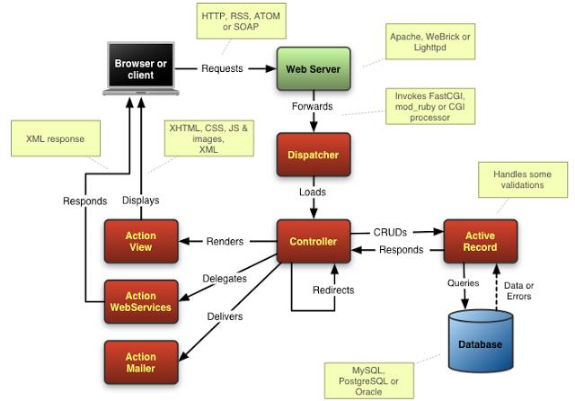

Data Model

E-R Diagram
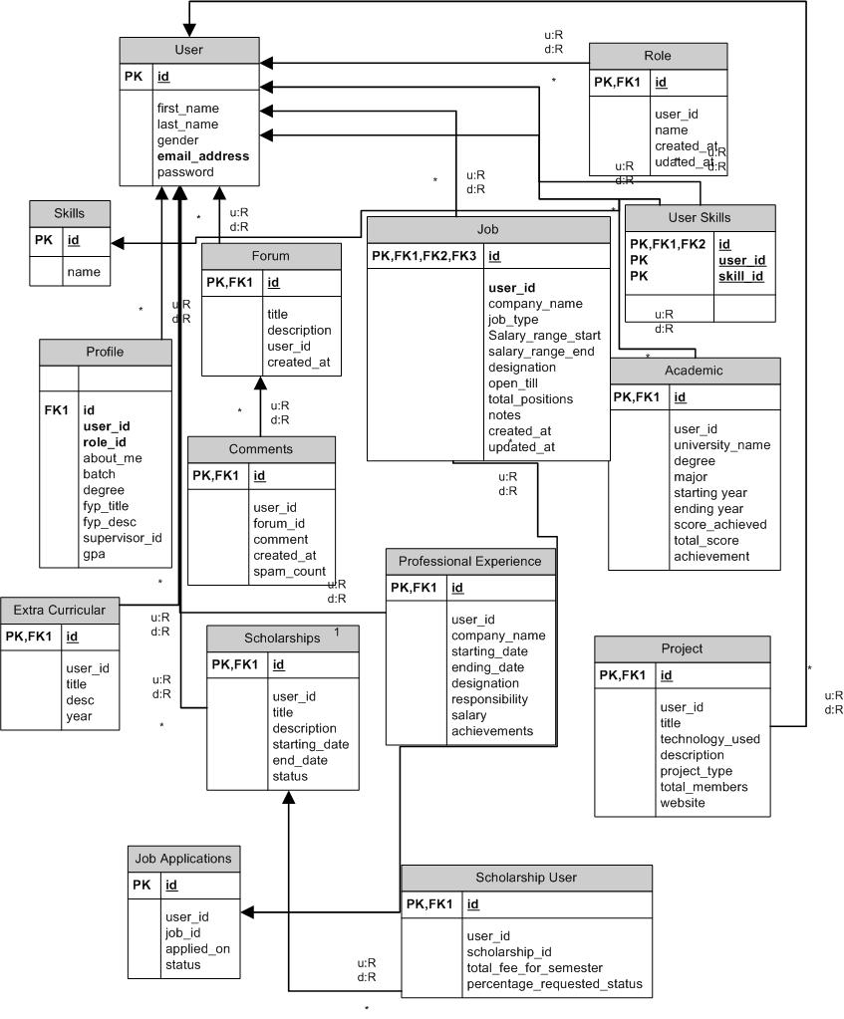

Data Flow Diagram

Overall system

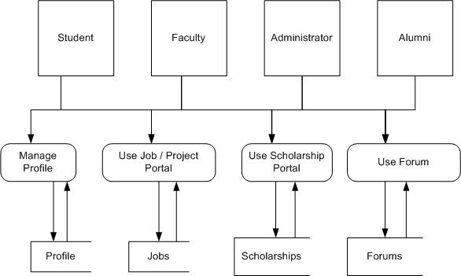

Profile Management

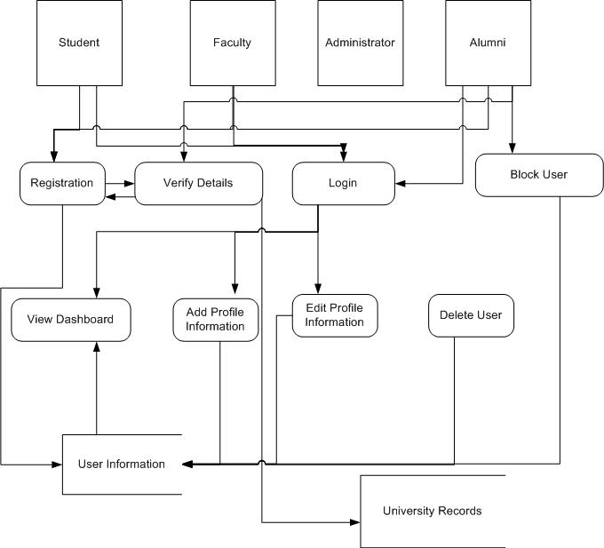

Job portal

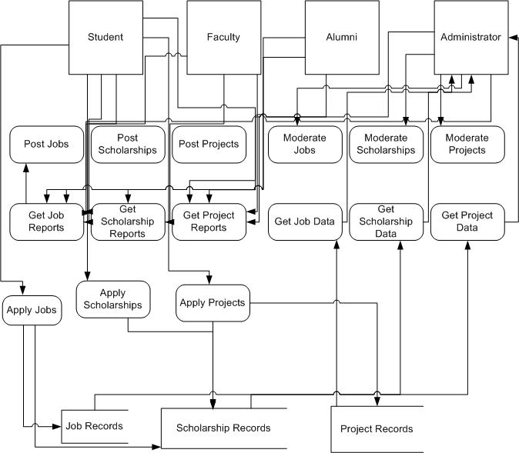

Forum

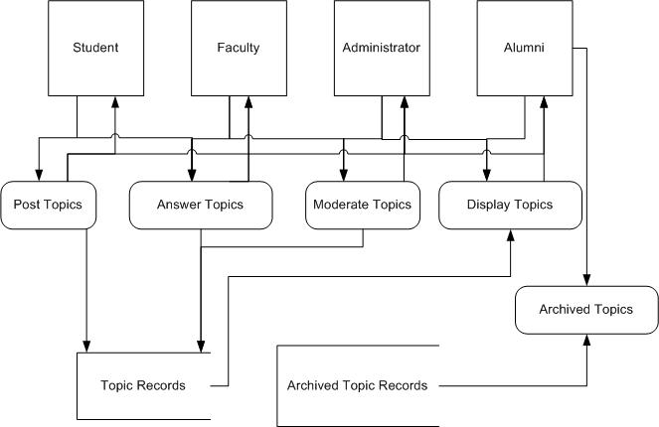

Object Model
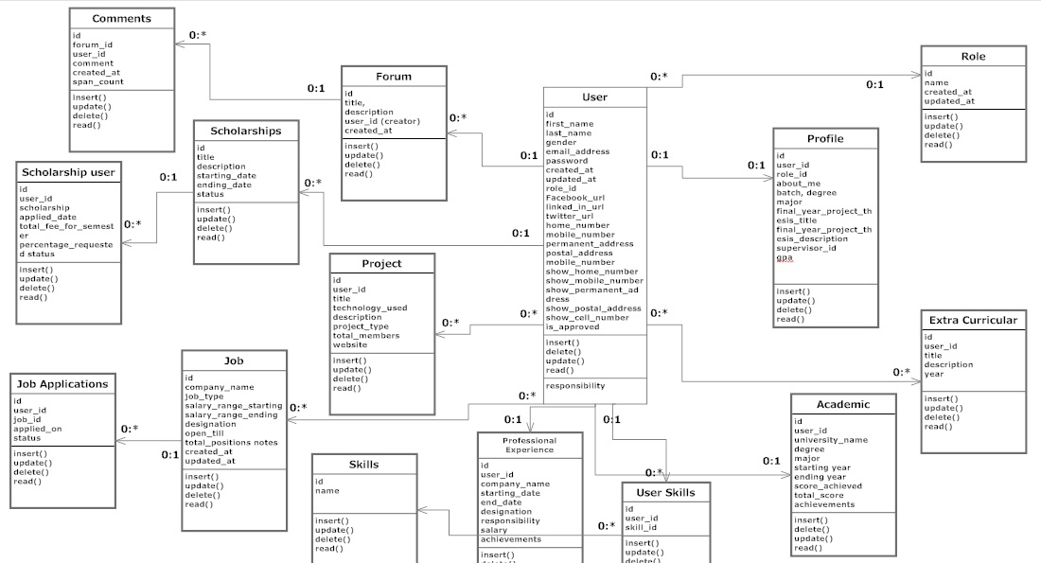

GUI(s)

Home Page
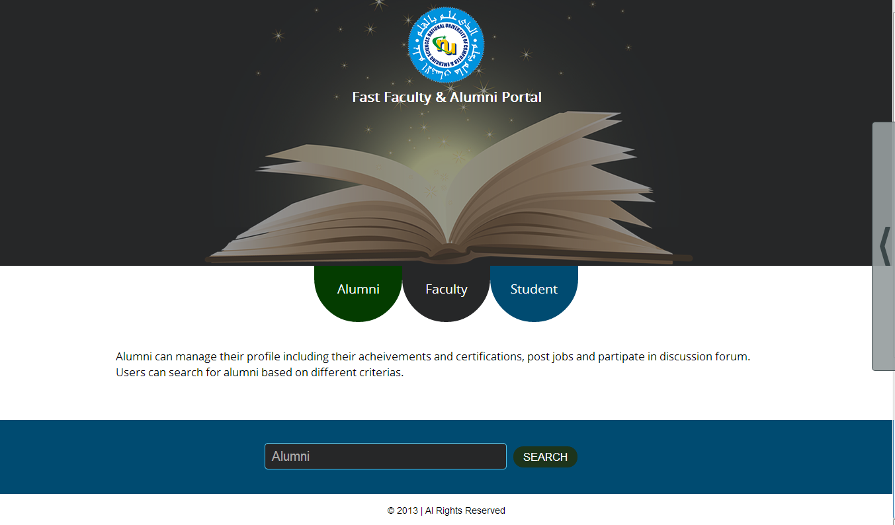

Login Page
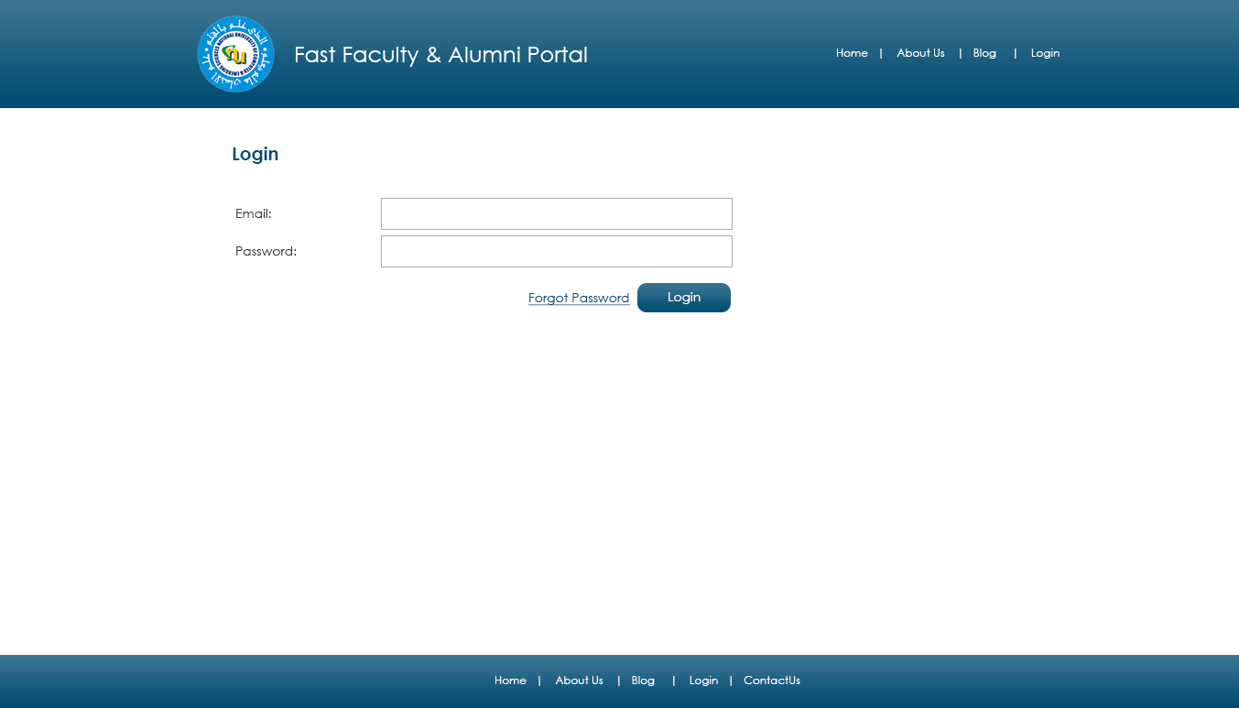

Registration Page
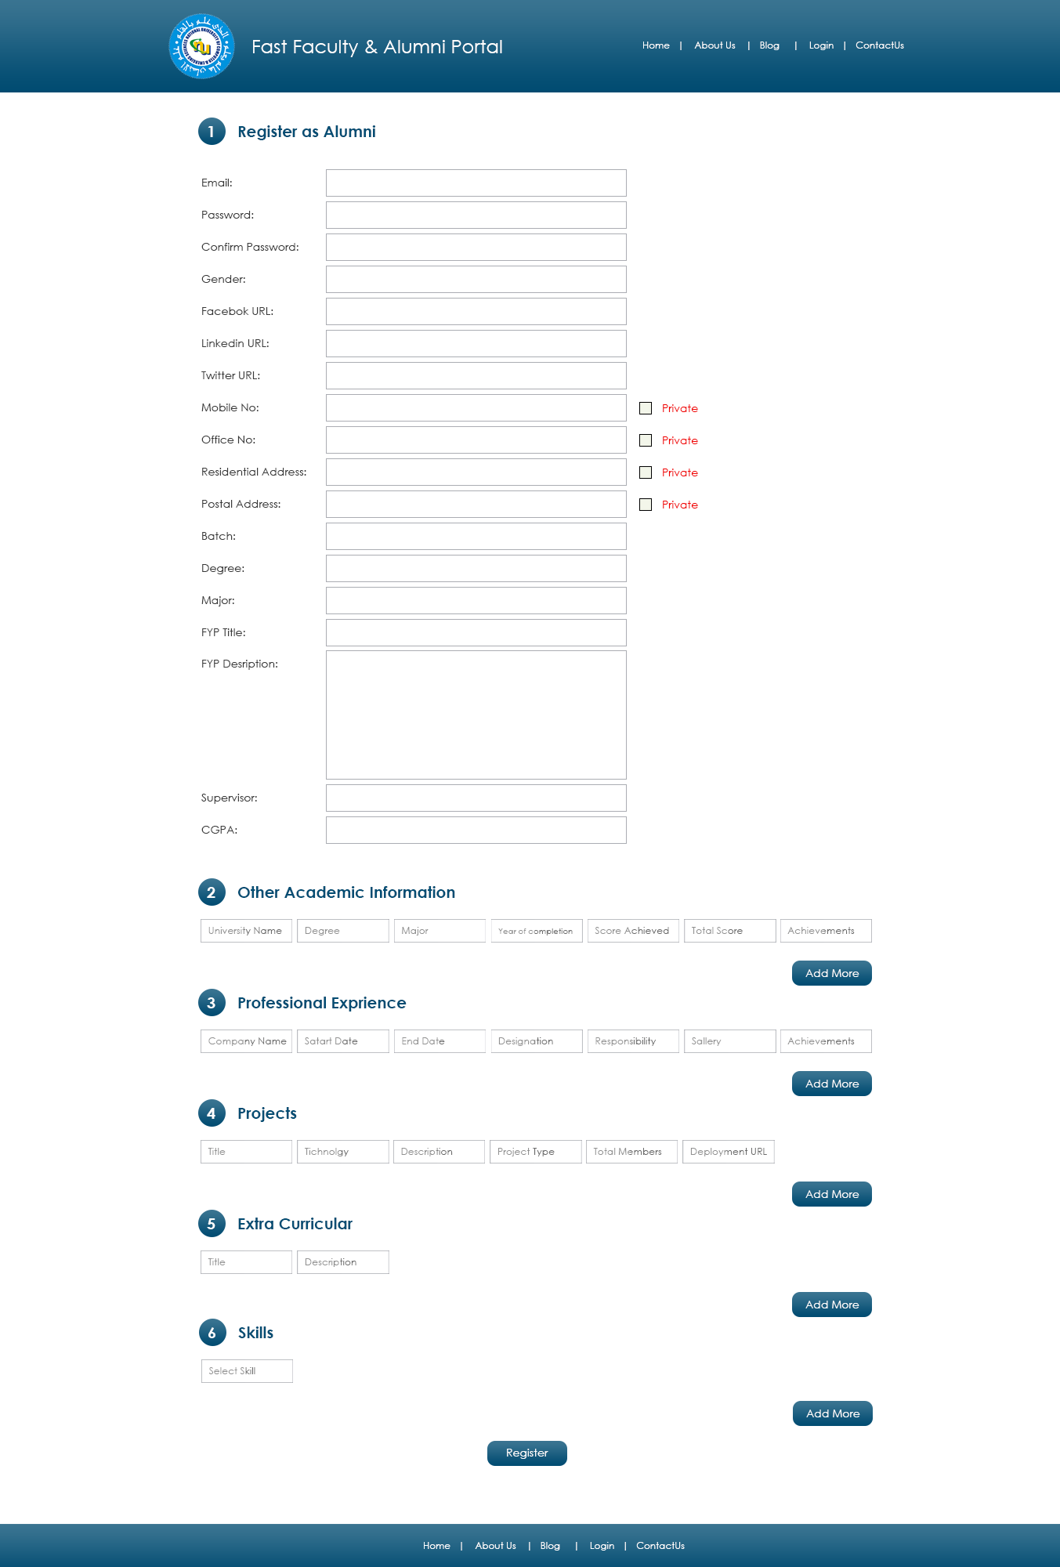

Profile Page

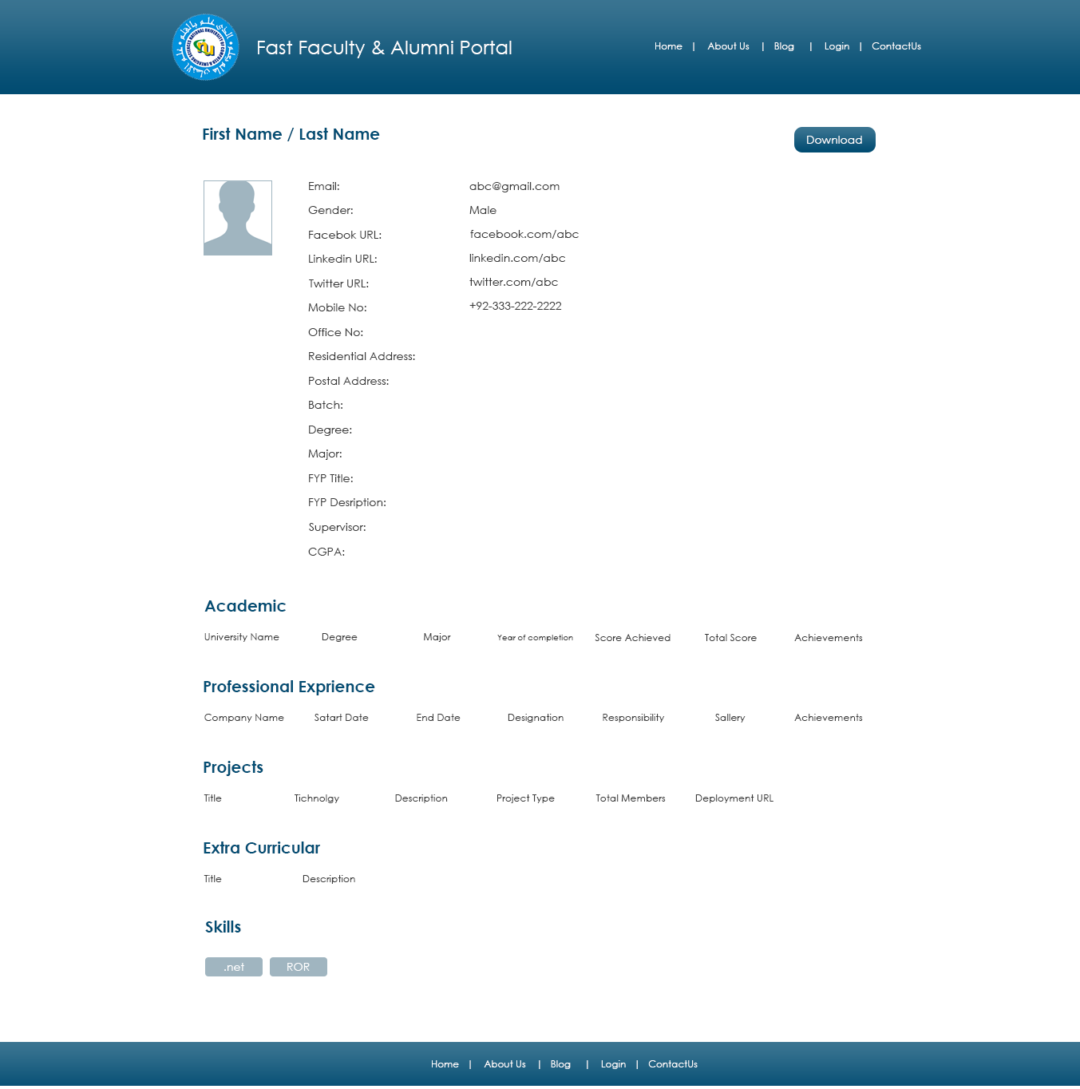

Edit Profile Page 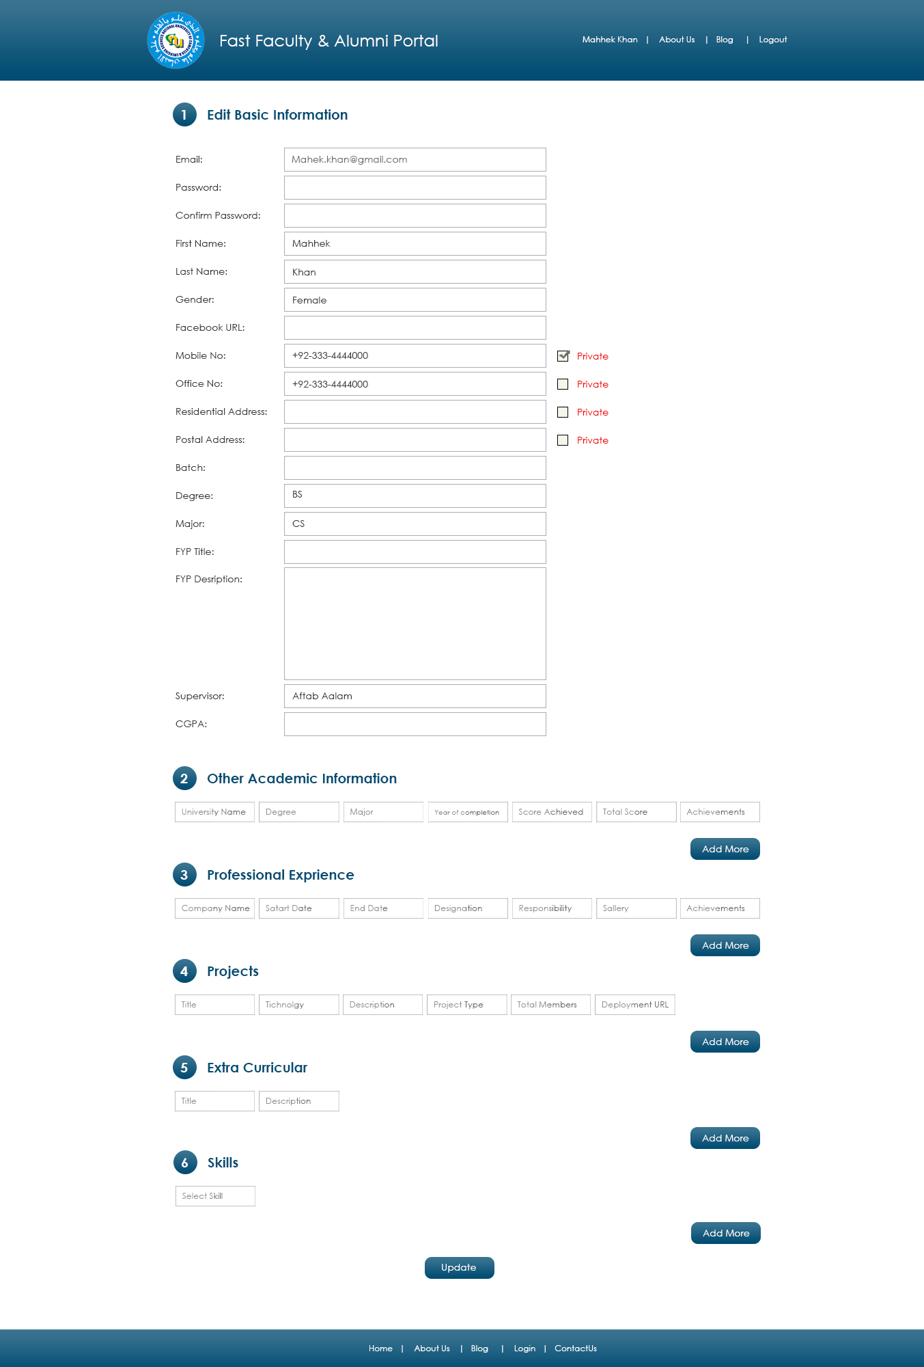

Edit Password Page

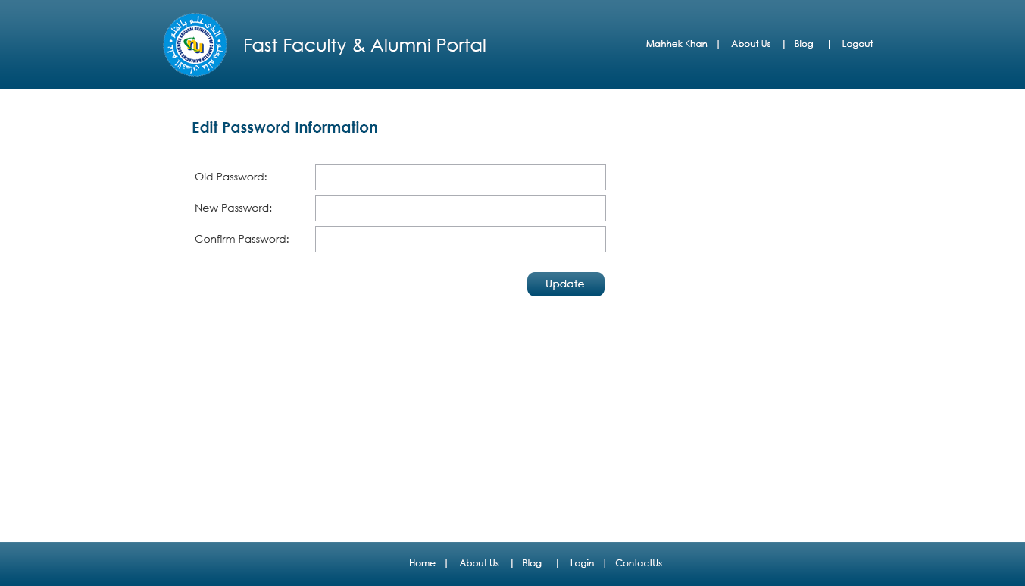

Post Job Page
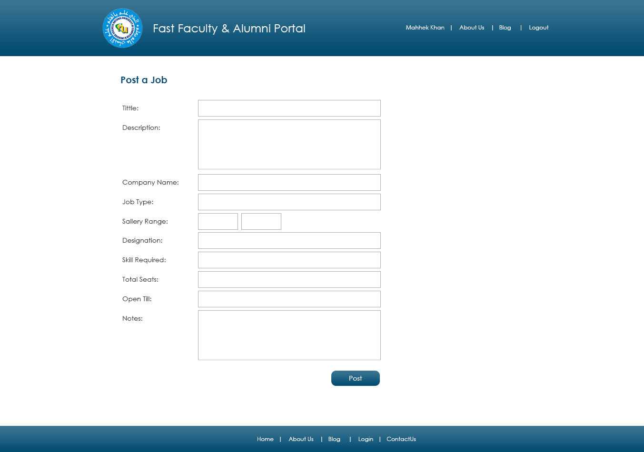

Search Job Page
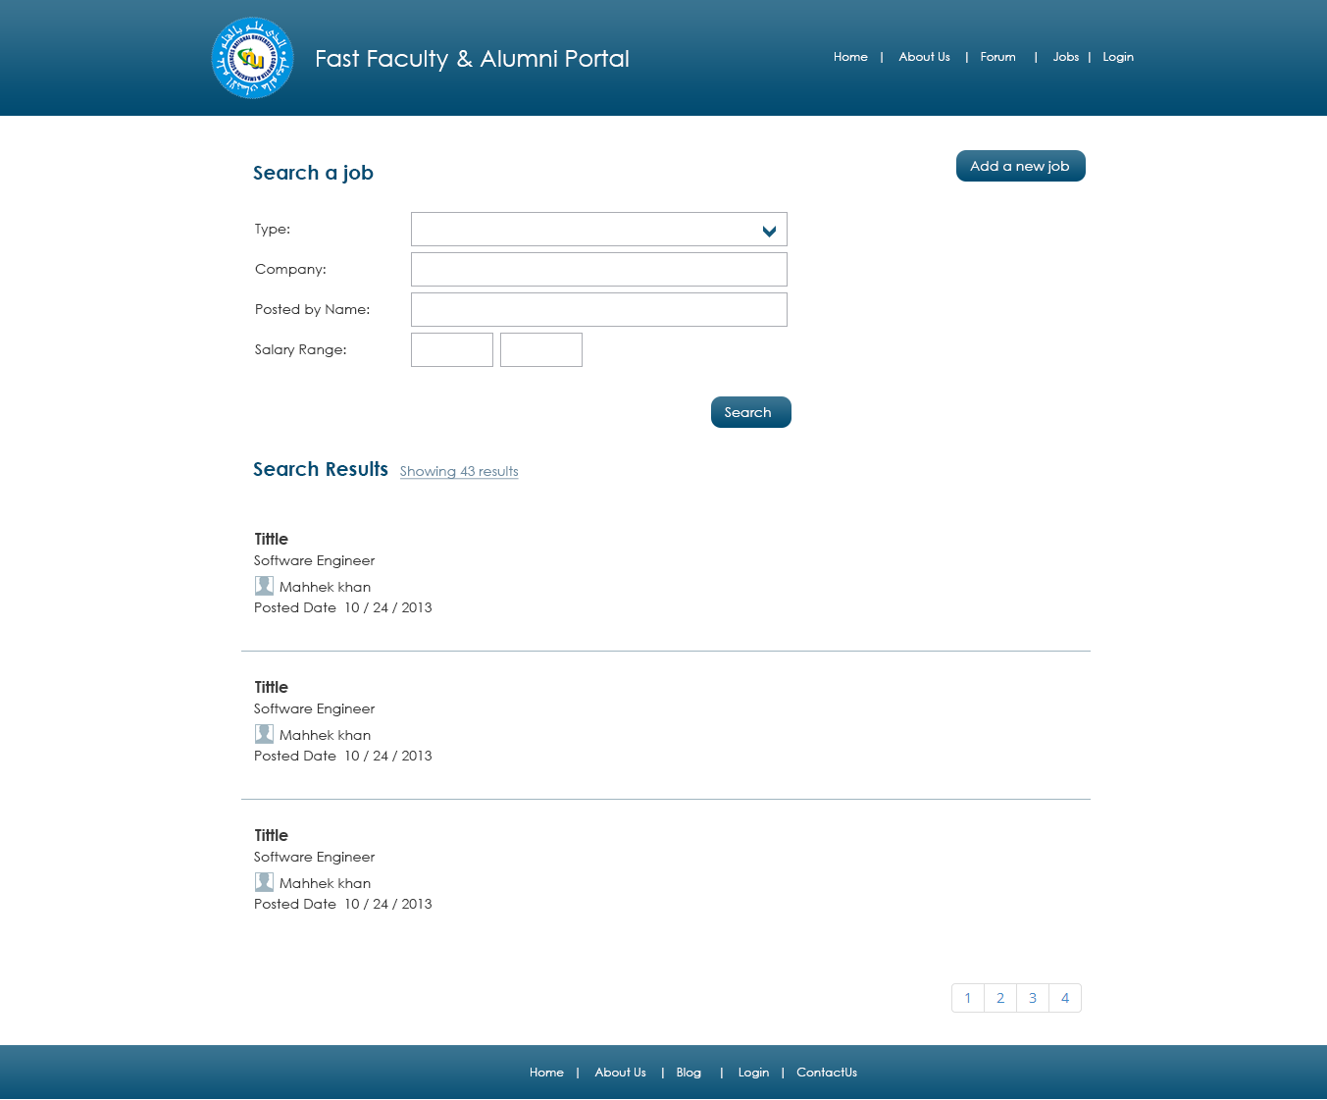

Job Detail Page
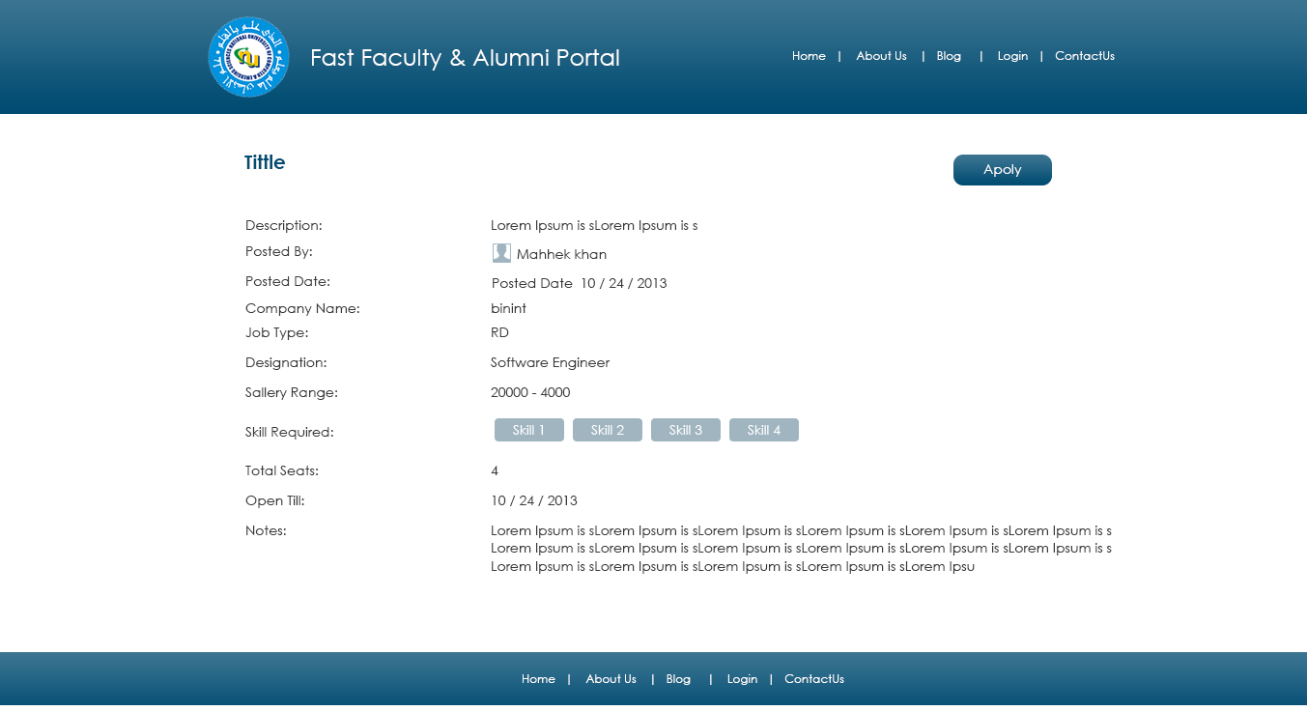

Discussion Forum Page
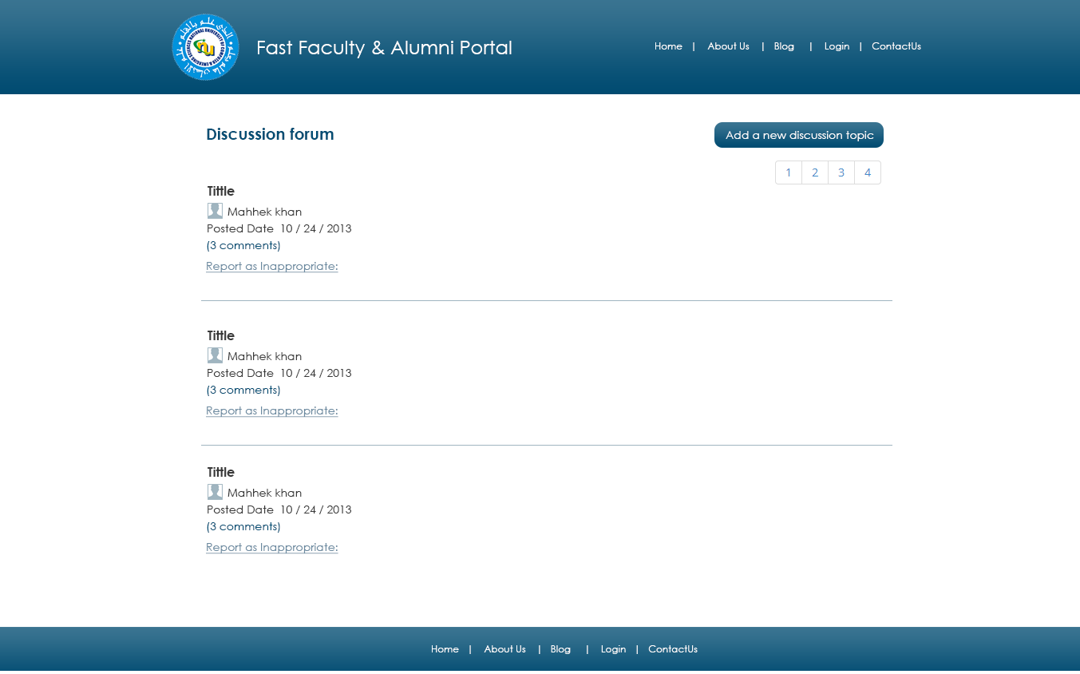

Topic Detail Page
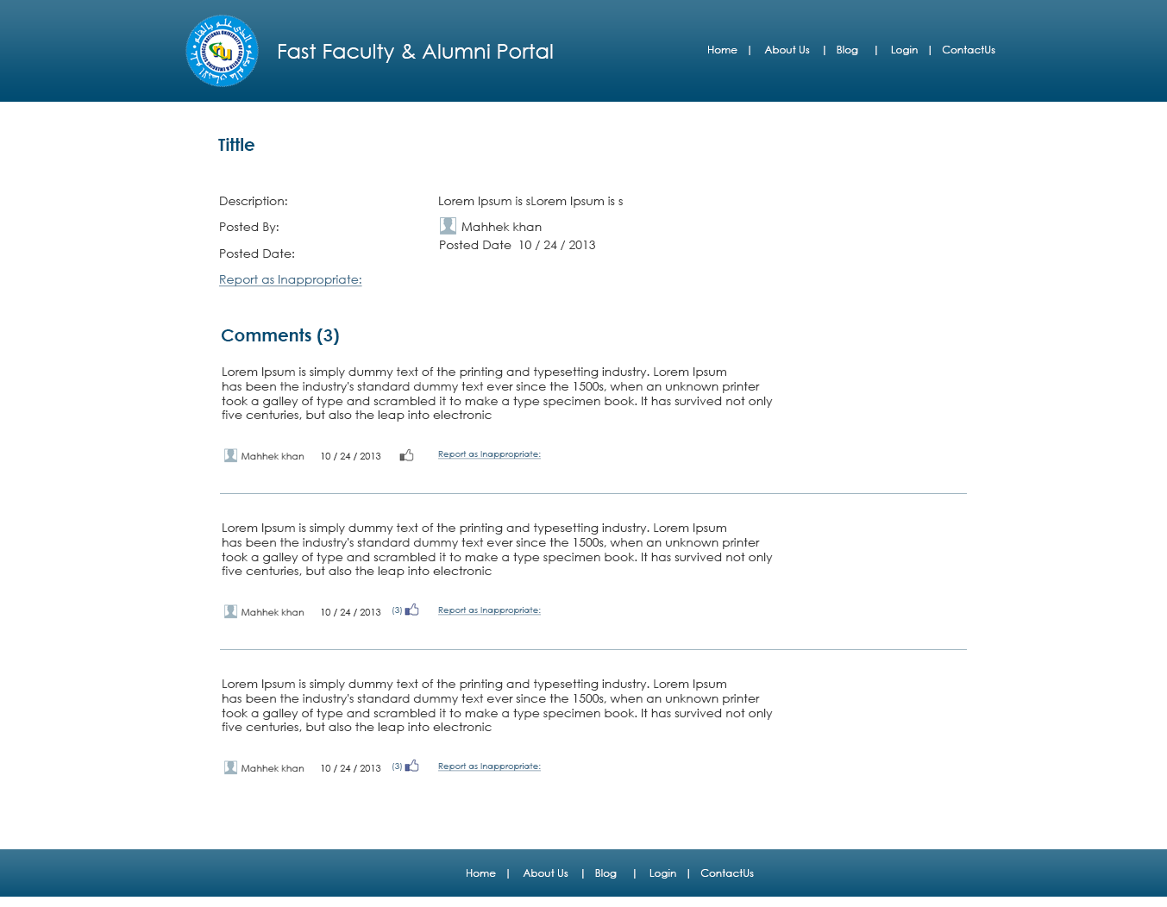

Create Topic Page
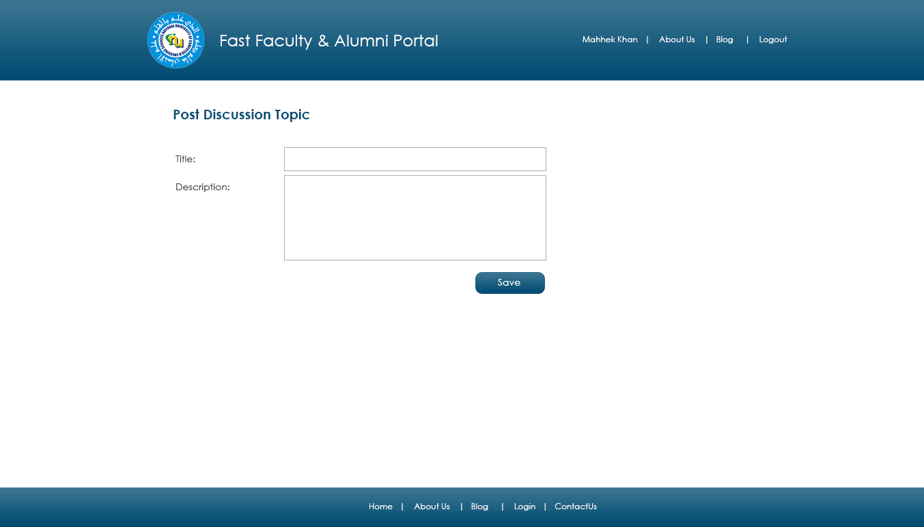

Scholarship Page

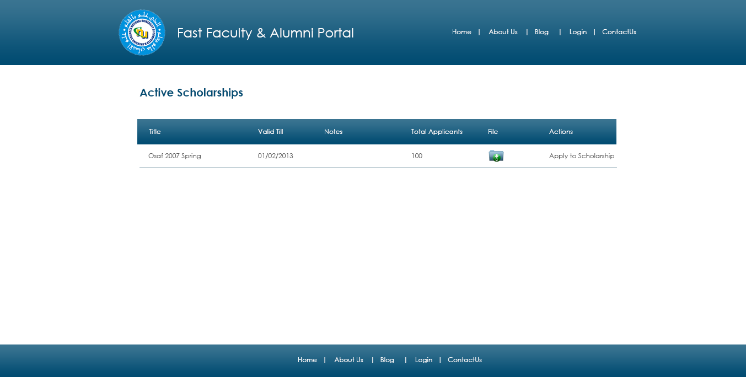

Alumni Search Result Page

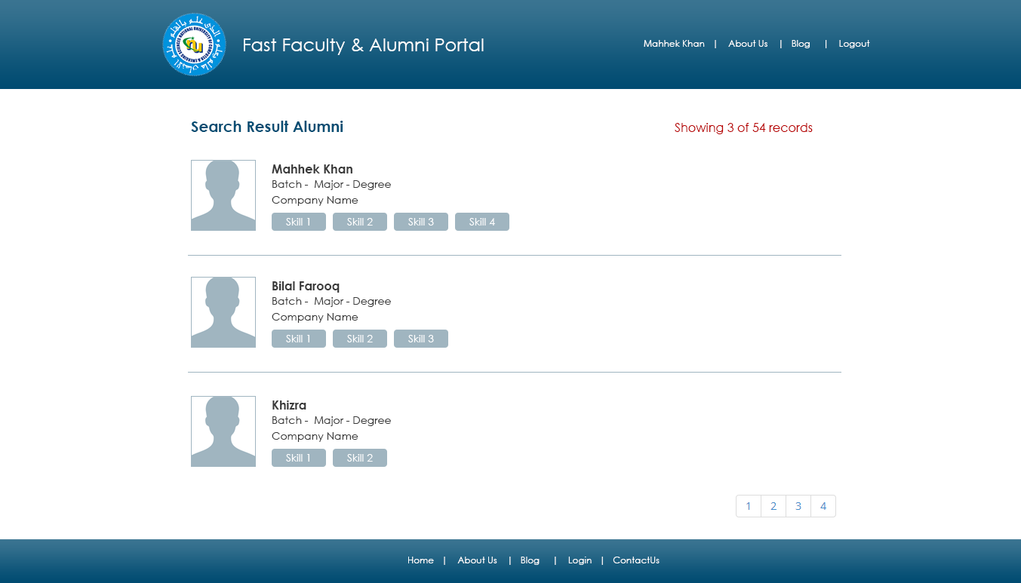

Faculty Search Result Page
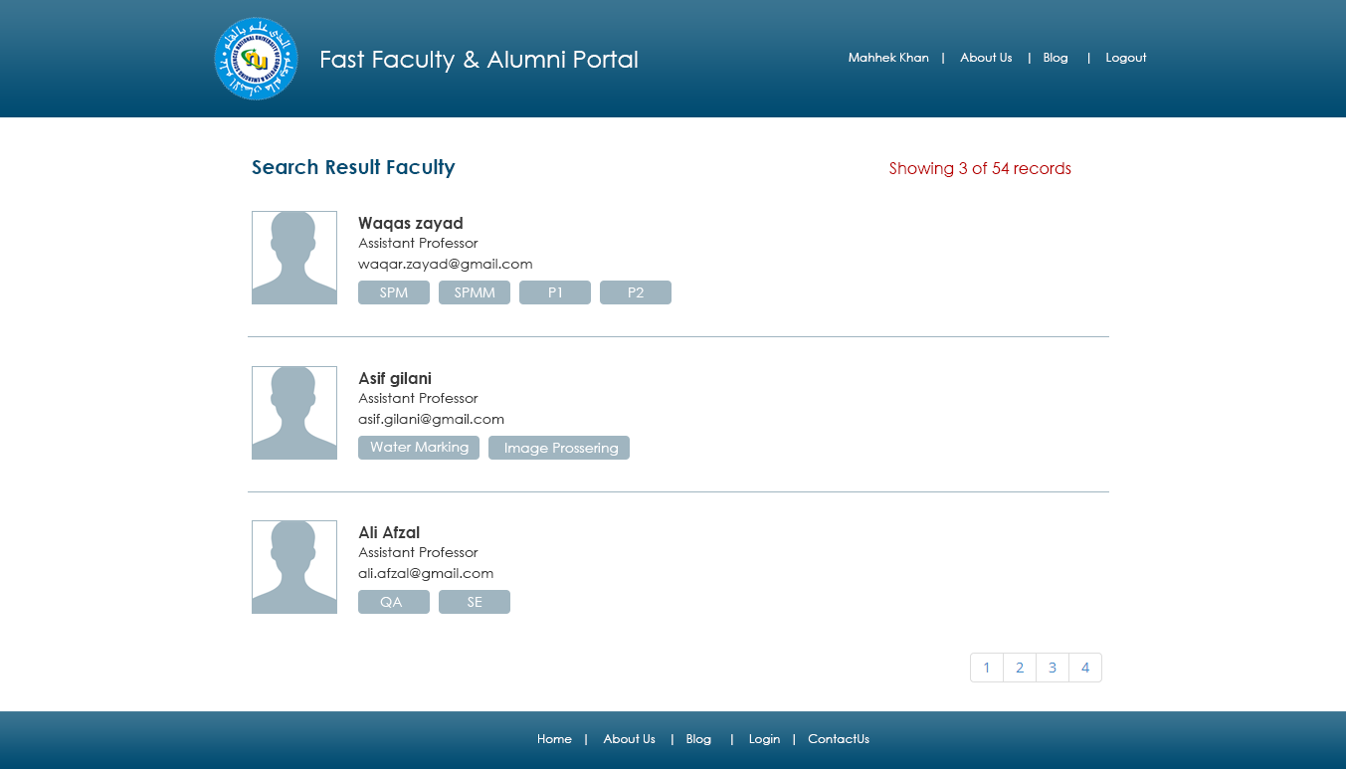

Student Search Result Page
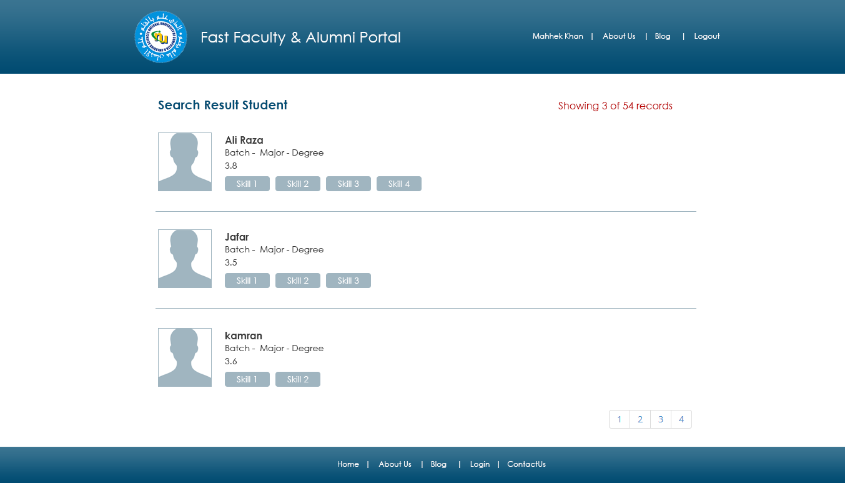

Admin Dashboard

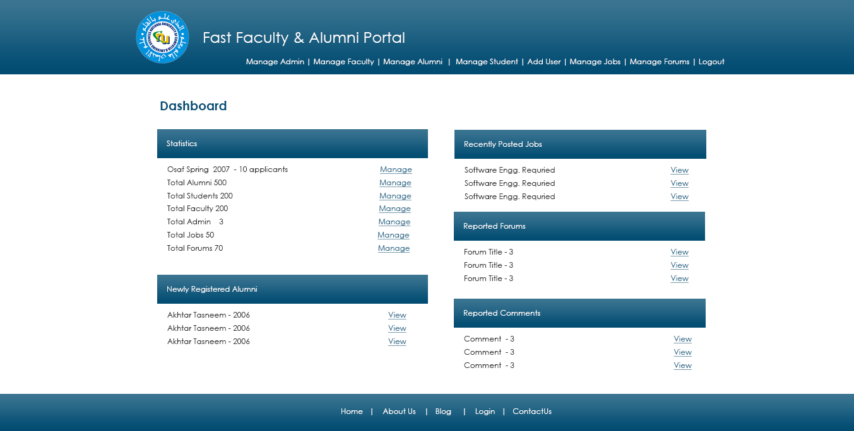

Add New User Page

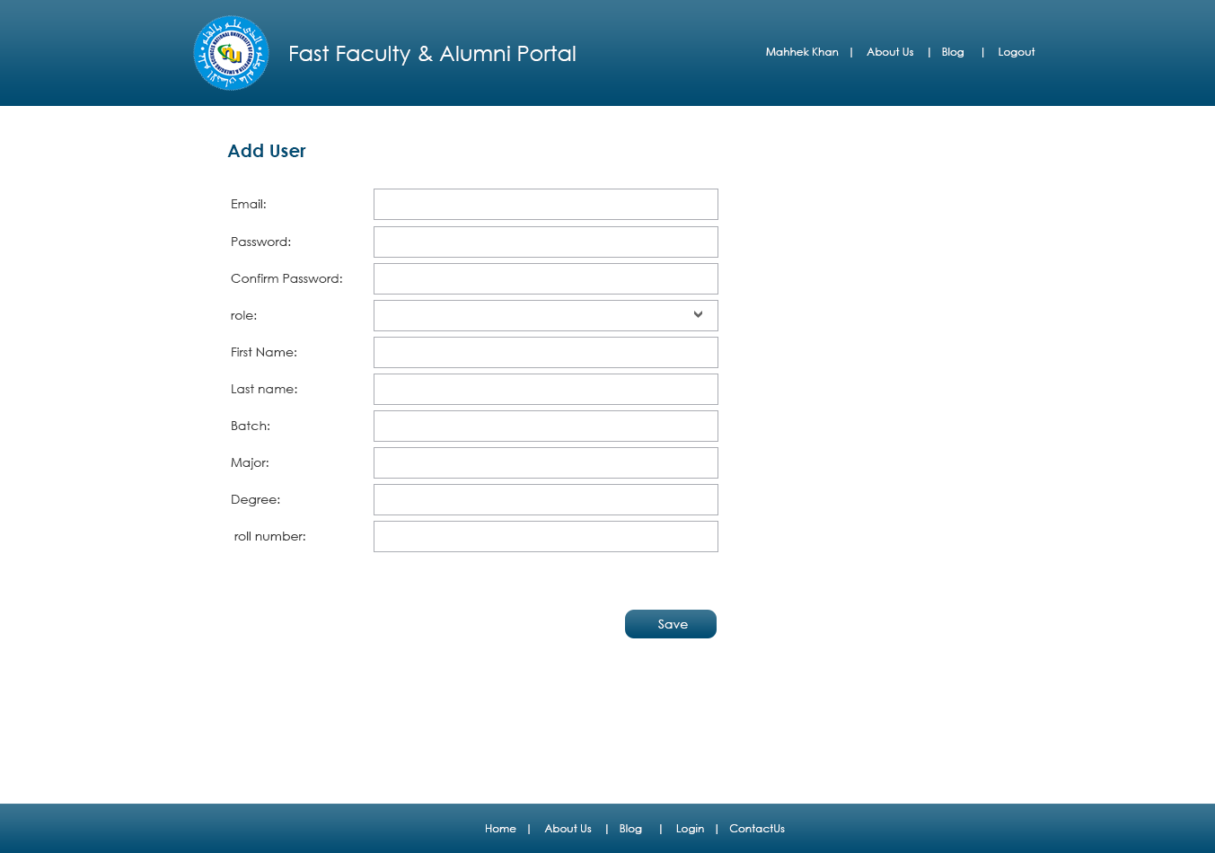

Manage Alumni Page

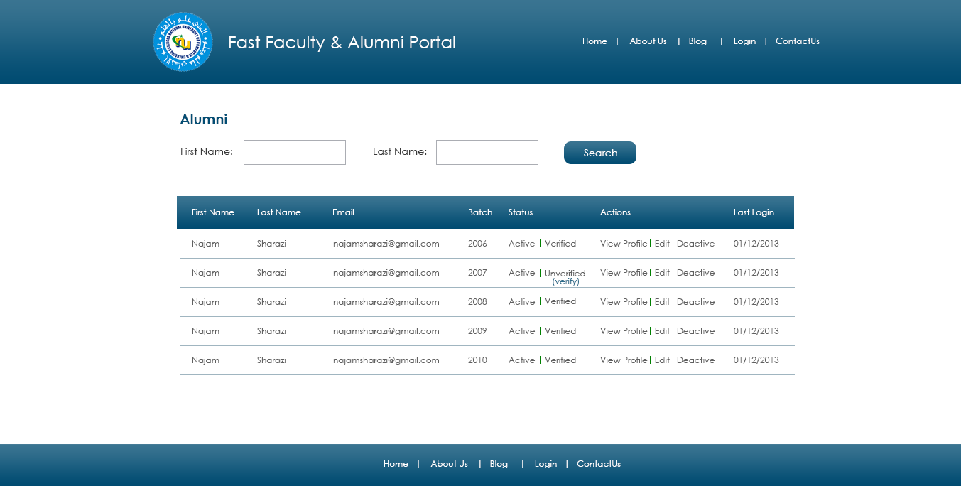

Manage Faculty Page
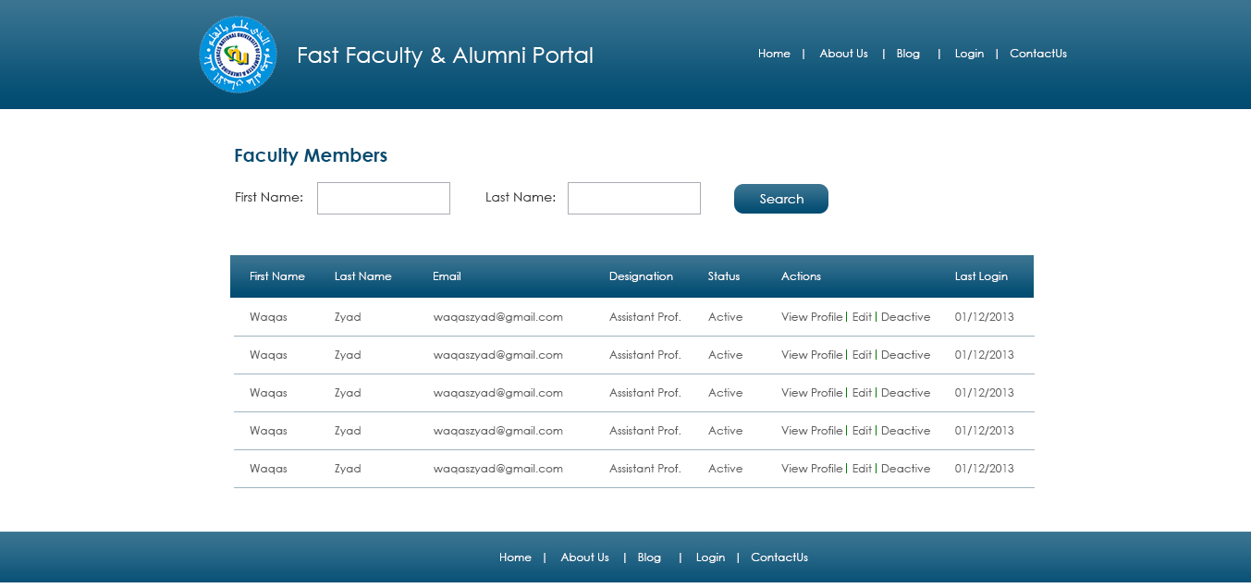

Manage Jobs Page

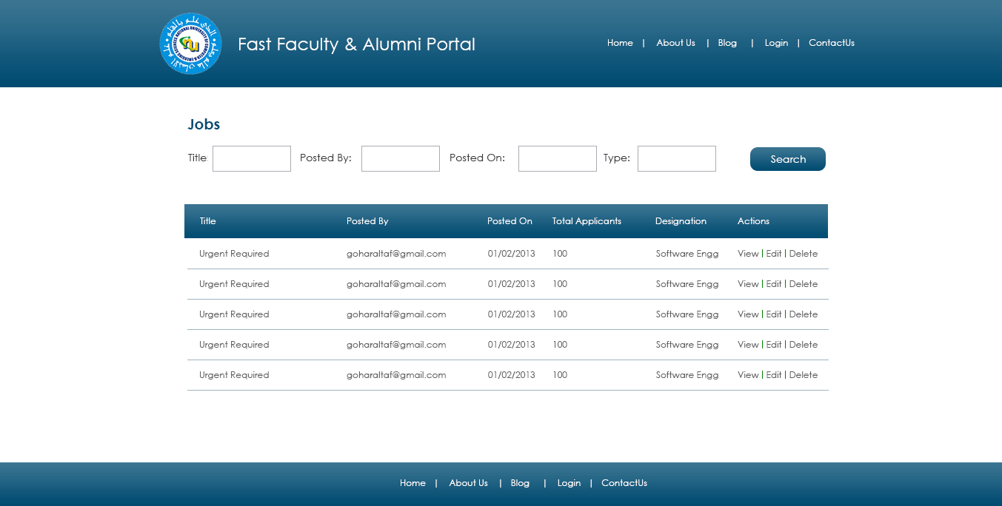

Manage Student Page
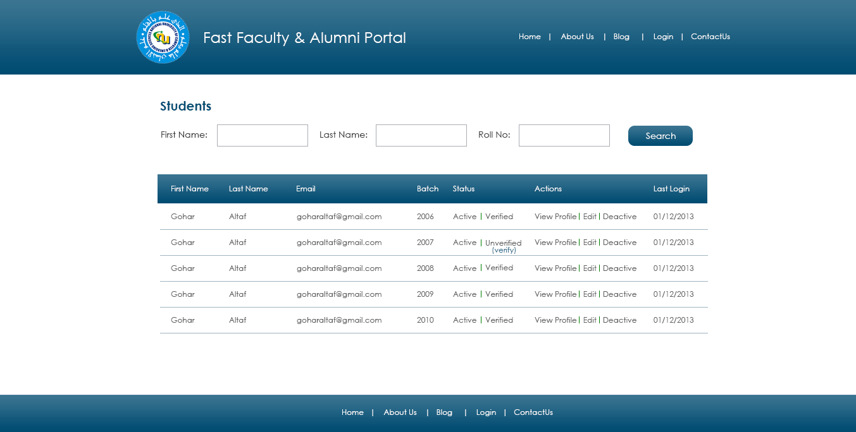

Manage Scholarship Page
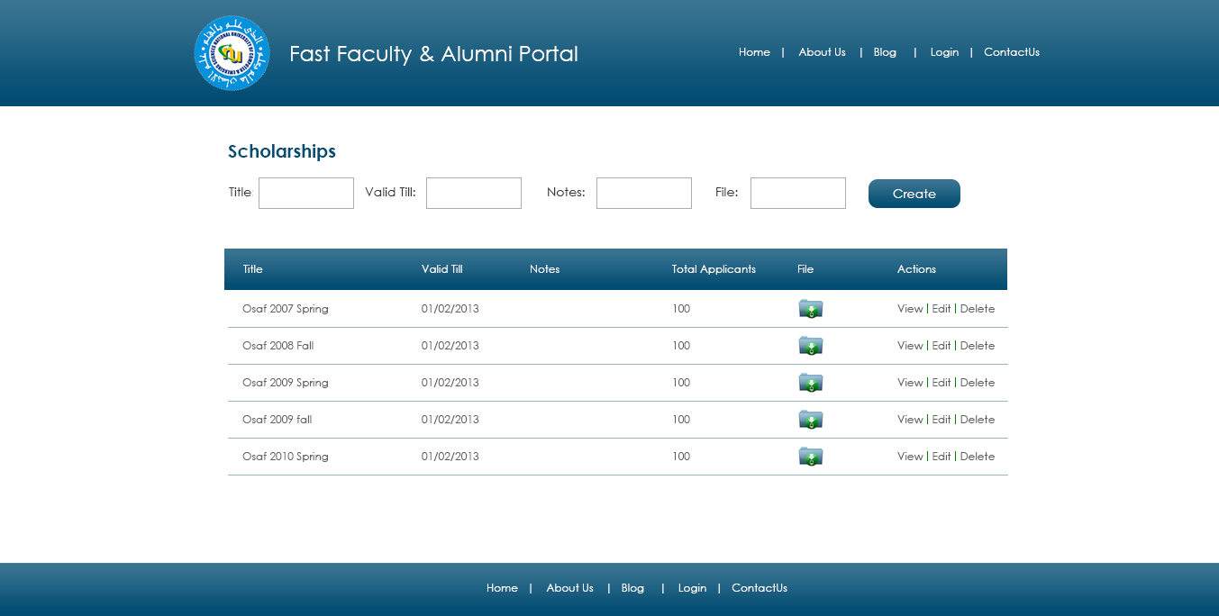

Manage Discussion Forum
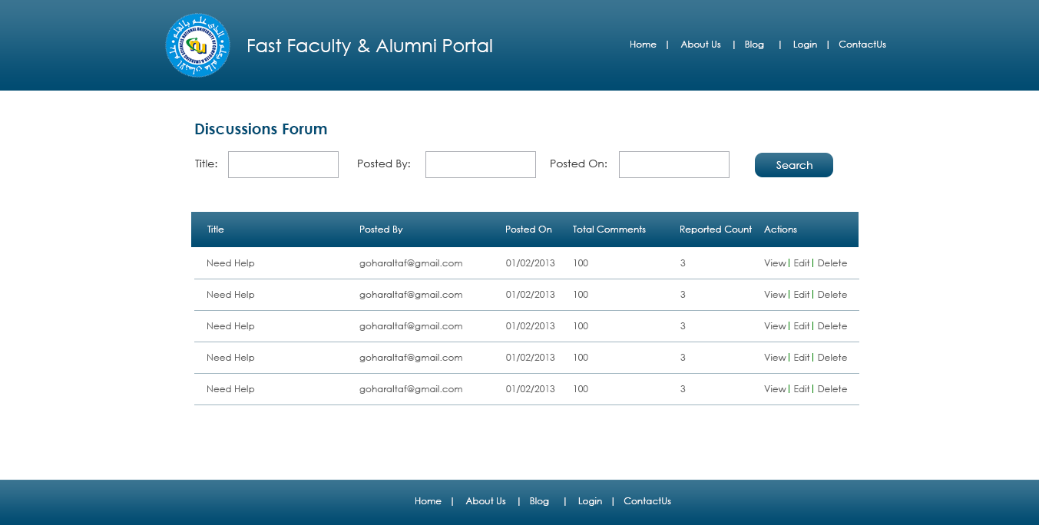

References
Requirement Specification - Alumni & Faculty Portal.doc
Project Management Plan - Alumni & Faculty Portal

